Discontinuity-enhanced icephobicity as a strategy for reduced ice adhesion on surfaces
Carlo Antonini¹*, Pablo F. Ibáñez Ibáñez^{1,2}, Luca Stendardo¹, Anny Catalina Ospina Patiño¹, Rajat Chaudhary^{1,3}, Irene Tagliaro¹
¹ Department of Materials Science, University of Milano-Bicocca, Milano 20125, Italy
² Laboratory of Surface and Interface Physics, Department of Applied Physics, University of Granada, Granada 18071, Spain
³ Glass & Ceramics Lab, Department of Industrial Engineering, University of Trento, Trento 38123, Italy

Abstract

Passive low ice-adhesion surfaces are frequently composed of soft materials; however, soft materials potentially present durability issues, which could be overcome by fabricating composite surfaces with patterned rigid and soft areas. Here we propose the innovative concept of discontinuity-enhanced icephobic surfaces, demonstrating that the stress concentration at the edge between rigid and soft areas
facilitates ice detachment.
Complementing experimental tests with numerical simulations, it was found that on a composite surface
containing rigid and soft areas, stress is concentrated at the edge between the two, i.e. at the discontinuity line, rather than all over the soft or rigid areas. As a result, ice detachment is promoted: the crack occurs first at the discontinuity line, propagates on rigid and then on soft areas. Moreover, it was demonstrated that an increase in discontinuities promotes crack initiation and leads to a reduction of ice adhesion. Remarkably, an unexpected non-unidirectional crack propagation was observed for the first time and elucidated.

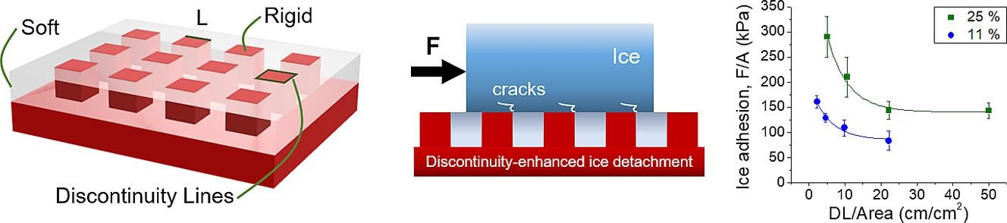
Figure 1: Schematic of discontinuity enhanced-icephobic surfaces (left), concept of crack initiation at discontinuities (center), and ice adhesion as function of discontinuity line density (right). Picture reproduced from [1].

References

- Ibáñez Ibáñez, P. F.; Stendardo, L.; Ospina, C.; Chaudhary, R.; Tagliaro, I.; Antonini, C. Discontinuity-Enhanced Icephobic Surfaces for Low Ice Adhesion. Journal of Colloid and Interface Science 2025, 679, 403–410. https://doi.org/10.1016/j.jcis.2024.09.205.
- Ospina, C.; Ibáñez-Ibáñez, P. F.; Tagliaro, I.; Stendardo, L.; Tosatti, S.; Antonini, C. Low Ice Adhesion on Soft Surfaces: Elasticity or Lubrication Effects? Journal of Colloid and Interface Science 2025, 677, 494–503. https://doi.org/10.1016/j.jcis.2024.08.042.
- Stendardo, L.; Gastaldo, G.; Budinger, M.; Tagliaro, I.; Pommier-Budinger, V.; Antonini, C. Why the Adhesion Strength Is Not Enough to Assess Ice Adhesion on Surfaces. Applied Surface Science 2024, 672, 160740. https://doi.org/10.1016/j.apsusc.2024.160740.

Short Biography

Carlo Antonini received the BSc in Aerospace Engineering (2004) and the MSc in Aeronautical Engineering (2007), from Politecnico di Milano. and the PhD from University of Bergamo (2011), Italy. From 2012 to 2018 he worked in Zurich, first at ETH as post-doc, then at EMPA as scientist. In September 2018 he joined the Department of Materials Science at the University of Milano-Bicocca, Italy, where he created and leads the "Surface Engineering and Fluid Interfaces Laboratory" (SEFI Lab, sefilab.mater.unimib.it). In 2021 he got tenured as associate professor. From 2021 to 2025 he has coordinated the MSCA-ITN project SURFICE, Smart surface design for efficient ice protection and control (surfice-itn.eu), dedicated to the training of 13 PhD students in the field of icing and surface strategies to contrast it. In 2024-25 he is currently spending his sabbatical in Toronto, at YorkU and UofT.

