Evolution Processes in Polymeric Networks followed through low-field TD-NMR
Denise Besghini¹
¹Materials Science Department, Università di Milano-Bicocca, Milan, Italy
Polymeric networks, especially rubbers and hydrogels, are ubiquitous materials. The determination of their structure-property relationships is fundamental for their rational design.
Low Field (LF) Time Domain (TD) Nuclear Magnetic Resonance (NMR) is a powerful technique to probe molecular-level dynamics, analysing ¹H relaxation times T₁ e T_{2.} That becomes very useful when it is necessary to monitor time-dependent processes.
Thermo-gelation has been investigated on methyl-cellulose (MC) gels (1) with the study of T2 variation with temperature. T2 increases with temperature until a sudden drop, associated to the gel point, which is concentration dependent. The reversibility of the process, the formation of a metastable phase and the associated hysteresis phenomena can be observed, obtaining analogous results to rheological tests (Fig.1a,1b).
TD-NMR can also measure residual dipolar couplings (D_{res}), which are linearly proportional to the crosslinks density (CLD), according to the equation $CLD=\frac{D_{res}}{4πA}$ (2). This has been applied to evaluate the increasing number of crosslinks during the vulcanization process in a commercial rubber compound, with the concurrent reduction in the number of uncoupled chains with progression of the curing (Fig.1c). That reflected also on the more homogeneous distribution of crosslinks at end of the curing process.
Even the effect of overcuring at high temperatures in reversion conditions on network morphology can be monitored (Fig.1d). The overcuring induces a drastic change in the morphology with a relevant, but homogeneous, reduction in the CLD respect to the highest CLD accessible at that temperature. Moreover, a peak at even higher Dres appears for the overcured sample, indicating the formation of a much more inhomogeneous network, whose causes could be attributed either to the formation of clusters of monosulfidic bonds or to the association of freed chains to the surface of filler particles.
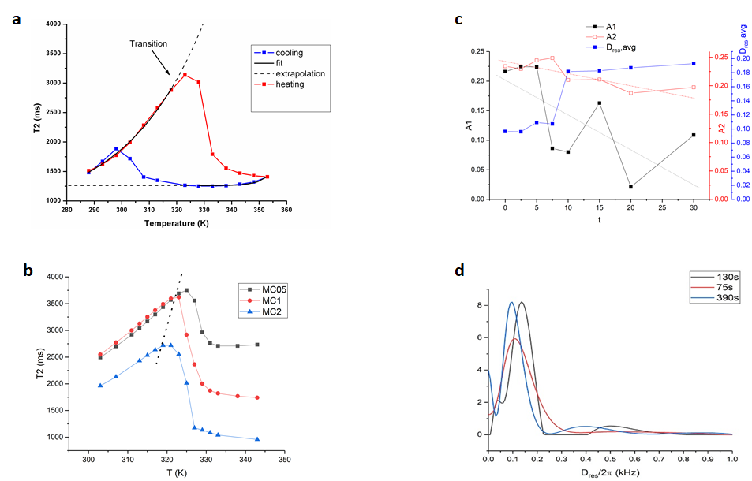

Figure 1. a) T2 relaxation time of MC during a temperature cycle (from 10°C to 75°C and back),
b) MC gelation for sample with different concentration with shift of gel points,
c) increasing of Dres and decreasing of % of network defects at longer curing time,
d) Dres distribution of undercured, cured at t90 and overcured samples at 190°C.

Bibliografia
1. P. Nasatto, F.Pignom, J.SIlveira, M.Duarte, M.Rinaudo, Methylcellulose, a cellulose derivative with original physical properties and extended applications. Polymers. (2015)
2. M. K. Dibbanti, M.Mauri, L. Mauri, G. Medaglia, R. Simonutti, Probing small network differences in sufur-cured rubber compounds by combining nuclear magnetic resonance and swelling methods. Journal of Applied Polymer Science. (2015)

