FINANCIAL CRISIS, ENVIRONMENTAL TURBULENCE AND INTERNATIONAL TRADE. THE CASE OF ITALY

Maria Garbelli, (Senior Lecturer.)
University of Milano Bicocca

Abstract:
In 2007 United States of America gave birth to a global, deep and disruptive phenomenon, well known as Financial Crisis. Despite the specific overseas location it first appears, the global crisis comes very fast in Europe, affecting several Countries in different ways and threating both Government and the economic tissue of the Nations. Since the crisis first appears, Italy has faced the global economies collapse: trade inside and outside the Nation felt down, with a loss of competitiveness of the Country compared to other EU’: lower earns and the credit crunch implicate a raise of failures cases, and a competitive position loss in several industries. Almost ten years after the crisis very begin, and using Italian data, the paper give a measure of the crisis impact on international trade geography for the Country.

Key Words: turbulence; export; Italy; performance; European Union
Introduction:
Abrogating the Glass-Steagall Act in 1999, United States started a regression phase coming out as the strongest financial crisis after 1929 in the whole Country, turning national economy to a crisis status in less than ten years.
If that situation seemed at first to be enclosed in the USA restricted area, time showed a fast and widespread evolution of the negative crisis effects to Europe and to several economies connected with the States: according to the International Monetary Forum, GDP has dropped 0,6% worldwide; also, production felt for 8,2% while international trade dropped for 10,6% (www.imf.org). Nevertheless, while some Countries, basically in developing areas (such as India and China) revealed weak reactions and limited loss, the most industrialized have been severally injured, with dramatic consequences on their economic equilibrium.
Since the crisis very begin, public authorities have tackled the topic in several ways, considering the impact of the crisis on their Country, the society, the economic tissue and the single business. Accordingly, scientific literature dealt with the crisis impact and on turbulent environment features: in fact, due to its effects on global markets, financial crisis could be assimilated to a factor generating environmental turbulence, in a global context qualified by interconnection, hypercompetition and unpredictability (D’Aveni,1994).
Although a simple, direct consideration of the impact of the crisis on both international trade and a single business equilibrium can not be detected, for the simultaneous influence of multiple factors, it is a matter of fact that some phenomenon presents a clear, specific timing: for this reason, and with the above mentioned limitation, it can be of interest to give a quantitative approach on business failures and international trade tends in post-crisis years.
Accordingly, the aim of this paper is to give a quantitative comprehension of the crisis effects on a specific Country – not geographically related to USA, but facing direct connection with turbulence. Data of failures and of international trade will be analyzed to frame the economic dynamics emerged in the country, since 2007. All the tables and figures listed hereafter are Author’s elaborations.

Literature review
General environment (Hitt et al., 2015) is a classification of the environment, the pattern of all external conditions and influences affecting a company’s life and development (Mintzberg et al.,2002), that have been classified over time in several and well known ways: internal and external; national, regional or local, according to the criteria we intend to apply.
Its features, related to unpredictable changes and turbulence, have dragged literature attention for its effect produced on the economic frame of a Nation and on the single company itself: both literature and practitioners tackled the topic in order to support businesses in global but turbulent times, linking theory and empirical studies. For instance, Mella and Gazzola (2016) recognize the challenge for companies in global markets, to manage the best the unpredictable and fast features of a turbulent environment; Lambin et al. (2007) suggests a market driven approach to get closer to an over supplied market (Brondoni 2005), and serve it faster and better (Lambin and Brondoni, 2008). Considering the environment changeability, and distinguishing three different conditions – stable environment; a rapidly changing environment; turbulent environment (North and Varvakis 2016), the specific features of a quite stable and predictable environment, giving businesses time enough to organize the available resources, and thus their lifecycle, as external disruptive changes are few and easy to be predicted and demand’ request is beyond the offers production abilities (Brondoni, 2008), seems to be the most favorable. On the contrary, turbulent environment features – basically, unpredictability (Emery and Trist, 1965), lack of control (Stigter, 2002) or Volatility, Uncertainty, Complexity, Ambiguity, following Steihm and Townsend (2002) classification, has frequently been associated with crisis situations such as recession – a negative economic growth lasting for 2 or more consecutive quarters (Okpara and Wynn, 2007; Sobri et al, 2016). Turbulence is not a recent idea: dates 1990 Ansoff and Mcdonnell’ work on unsteady environment and defining a multilevel model to distinguish five levels of turbulence (repetitive, expanding, changing, discontinuous and surprising); more recently, several Authors used the same classification as a framework for their research (Kipley and Lewis, 2009; Kurtz and Varvakis, 2016).
Turbulence has also been recognized as a factor influencing both people attitudes and economic activities: for instance, some Authors (Aharoni, 1966 and more recently, Sobri et al., 2016; Gergely, 2016) found an unsteady and uncertain environment affect entrepreneurial attitudes (Okpara et al. 2007) and learning orientation, eroding creativity, innovativeness, open vision and risk taking. In the late sixties, Aharoni (1966) also recognized uncertainty as related to ignorance (due both to lack of information and lack of knowledge) and perceived change. In this sense, turbulence can influence international trade commitment due both to the managerial attitude toward exporting and to managers' perceptions of export market uncertainty in crisis times (Yu, Lindsay, 2016), and this seems to confirm theories on export performance determinants (Zou and Stan, 1998; Moini, 1995; Katsikeas et al., 2000; Carneiro et al. 2011).
To face the economic recession they live in their home country (Cavusgil 1981; Enderwick, 2009; Stoian et al., 2011; Bhanu Murthy et al, 2013), companies look outbound to find new destinations for their products increasing export performance (Ganotakis et al., 2012; Yu, Lindsay, 2016; Garbelli 2017) and this is of particular relevance for SMEs - Small and Medium Enterprises (Shoham, 1998; Maurel, 2009; Stoian, et al. 2011; Raymond et al., 2014; North and Varvakis, 2016) for their structural lack of resources (Golovko and Valentini, 2011).
In a global environment, qualified as above described, Literature recognizes exports playing a vital role in the SMEs strategies (Johanson et al, 1977; Welch et al, 1988; Styles, 1989; Moini, 1995; Johanson et al, 2009; Lages et al, 2009; Fernandez-Mesa and Alegre, 2014) and the existing link between exports and their performance (Stoian, et al. 2011) could help explaining the economic constraint several European Countries had to face during crisis. Europe is basically made of Small and Medium Enterprises, representing 99,8% of all the economic tissue of the Union, according to the annual report EUROSTAT 2016 (www.ec.europa.eu).

Methodology and research hypothesis
Following the aim of the paper, a specific Country identification is needed to follow with a quantitative approach highlighting the negative crisis effects. Italy is considered in this analysis for the economic unbalance due to 2007 financial crisis: several government Authorities, worried for the negative impact generated by the turbulence, published data and reports on the economic effects of the crisis on the Country and Local Business Associations as well, to face worries and difficulties expressed by entrepreneurs in the whole Nation.
Identifying 2007 as the year the financial crisis first marks in United States, we consider 2008 the first year the very direct effects of the crisis emerge overseas, in Italy and in Europe as a whole. 2009-2010 is considered the eye of the financial crisis of the country, whilst 2014 can widely be identified as the break even point to overcome the recession phase in Italy.

Figure 1 – the link between financial crisis, international trade and failures rate
FINANCIAL CRISIS
FAILURES RATE

INTERNATIONAL TRADE
The hypothesis to be verified in this paper concern the existence of a direct, negative link between international trade and financial crisis, and the connection between both and a loss of economic equilibrium, measured by a growing trend in business failures rate.
Accordingly, the main research questions are listed:
RQ1: Has financial crisis a direct relationship with international trade evolution?
A clear identification of the crisis impact on international trade must be highlighted. For this aim, it must be clearly stated if an impact on international trade trend has been realized and if a country destination change occurred, so the following two sub questions emerged:
SRQ1.1: Has financial crisis affected international trade?
SRQ1.2: Did the crisis modify the geography of international trade?
To answer the first research question, export flows have been identified to underline the link – if such a link can be outlined, between the crisis marks and international activities of the country.
RQ2: Has financial crisis threatened for real businesses existence?
Using Italian failures data we will try to check if the steps just considered can really fit Italian economic trend or not. Cribis data are collected and critically analyzed. With this aim, two sub questions were defined:
SRQ2.1: Has Italian failures rate changed considerably after 2008?
SRQ2.2: Have the country businesses become strong enough to overcome the post-crisis collapse?
Data are found on two main on line databases:
- the first is the national official database of ISTAT, the Italian Statistics institute. Istat national data warehouse, can supply the import/export data, useful to answer the first research question;
- the second attain a private institute named Cribis and well known nationally, as depute to provide professional support to businesses.

Results
Following the research idea underneath the paper, the first topic to investigate concerns the relationship among financial crisis and International trade during post crisis time.
RQ1: Has financial crisis a relationship with international trade evolution?
A better comprehension of the link between crisis and international trade follows the sub questions, in order to detail international trade trend since 2008.
Thanks to Istat database we have access to the import-export data by regions and Countries worldwide. In this step, we use the total amount of import and export data. The following table 1 details Italian export flows and their variation.
Although the first export brake emerged in 2008, with a very limited export growth, the flows collapsed in 2009 with a loss for around 21% of 2008 flows, but followed by a suddenly rise the very next year. In 2011 pre-crisis levels were established.

Table 1 – Italian export flows worldwide
WORLD | 2005 | 2006 | 2007 | 2008 | 2009 | 2010 | 2011 | 2012 | 2013 | 2014 | 2015 | 2016
export flows  (in value) | 299.923.416.151 | 332.012.884.964 | 364.743.919.186 | 369.015.556.090 | 291.733.117.417 | 337.346.283.197 | 375.903.831.853 | 390.182.091.869 | 390.232.593.094 | 398.870.413.894 | 412.291.286.364 | 417.268.909.969
annual variation |  | 10,70% | 9,86% | 1,17% | -20,94% | 15,64% | 11,43% | 3,80% | 0,01% | 2,21% | 3,36% | 1,21%
variation based 2008 |  |  |  |  | -20,94% | -8,58% | 1,87% | 5,74% | 5,75% | 8,09% | 11,73% | 13,08%

Figure 2 - Italian export flows variation worldwide
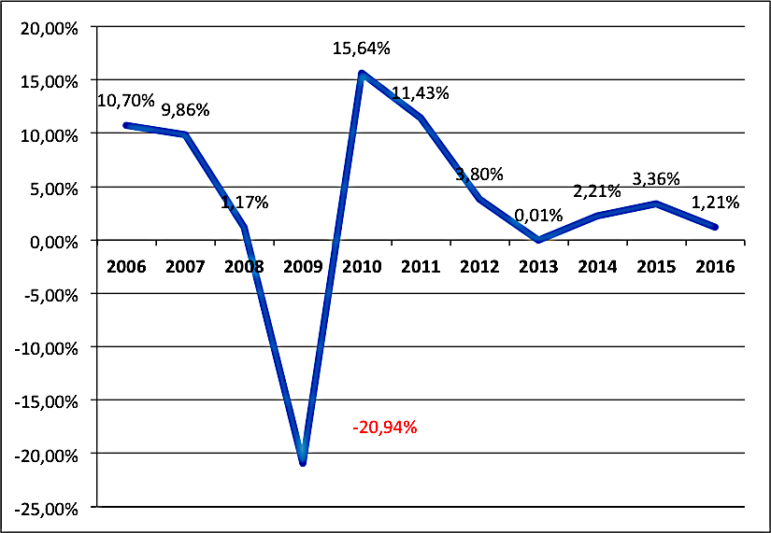

In a similar way, import analysis outline the 2009 collapse and the following fluctuating period.
If similarities are several, and attain both to the 2009 international trade collapse, and the following rise to pre-crisis levels in a couple of years, the main differences between import and export trends attain the post crisis variation: for the latter, no negative variation has been detected, whilst for import flows, a negative growth generates a contraction for 2012, 2013 and the following 2014. 2015 positive flows are followed by another negative rate in 2016.

Table 2 – Italian import flows worldwide
WORLD | 2005 | 2006 | 2007 | 2008 | 2009 | 2010 | 2011 | 2012 | 2013 | 2014 | 2015 | 2016
import flows  (in value) | 309.292.049.032 | 352.464.682.563 | 373.339.814.043 | 382.050.168.324 | 297.608.663.094 | 367.389.805.492 | 401.427.714.083 | 380.292.480.869 | 361.002.213.272 | 356.938.846.843 | 370.484.379.245 | 367.625.794.934
annual variation |  | 13,96% | 5,92% | 2,33% | -22,10% | 23,45% | 9,26% | -5,27% | -5,07% | -1,13% | 3,79% | -0,77%
variation based 2008 |  |  |  |  | -22,10% | -3,84% | 5,07% | -0,46% | -5,51% | -6,57% | -3,03% | -3,78%

Figure 3 – Italian import flows worldwide

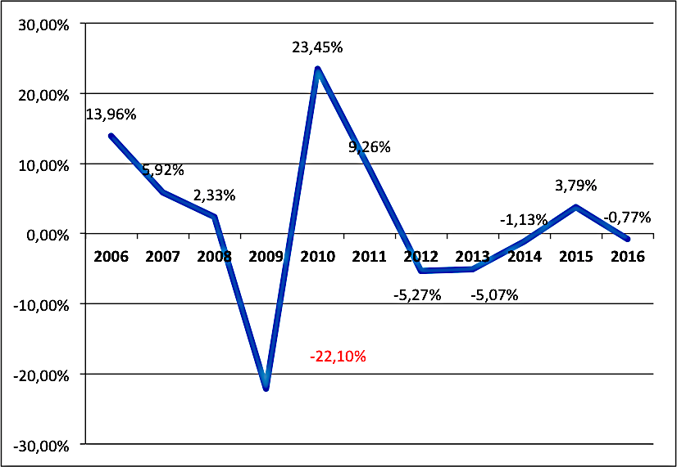
Using the same modus operandi, the following analysis considers the European Union Italian flows, to reveal very similar import and export trends. Compared to the international flows within the world, the EU’s give relevance to the fall noticed in 2012 and 2013.

Table 3 – Italian international trade flows with the European Union
EUROPEAN UNION | 2005 | 2006 | 2007 | 2008 | 2009 | 2010 | 2011 | 2012 | 2013 | 2014 | 2015 | 2016
Import  (in value) | 185.160.917.801 | 204.428.666.657 | 216.851.202.593 | 210.166.687.799 | 172.234.423.193 | 202.870.425.755 | 217.243.867.978 | 202.805.261.093 | 200.167.739.524 | 203.890.044.470 | 217.390.390.848 | 223.337.008.063
annual variation |  | 10,41% | 6,08% | -3,08% | -18,05% | 17,79% | 7,09% | -6,65% | -1,30% | 1,86% | 6,62% | 2,74%
variation based 2008 |  |  |  |  | -18,05% | -3,47% | 3,37% | -3,50% | -4,76% | -2,99% | 3,44% | 6,27%
Export  (in value) | 185.992.198.066 | 205.784.503.447 | 224.980.884.516 | 220.338.281.219 | 170.322.816.710 | 195.461.670.690 | 212.933.734.725 | 211.867.374.027 | 209.828.577.237 | 218.823.664.613 | 225.975.281.928 | 233.412.888.872
annual variation |  | 10,64% | 9,33% | -2,06% | -22,70% | 14,76% | 8,94% | -0,50% | -0,96% | 4,29% | 3,27% | 3,29%
variation based 2008 |  |  |  |  | -22,70% | -11,29% | -3,36% | -3,84% | -4,77% | -0,69% | 2,56% | 5,93%

Figure 4 – Italian international trade flows with the European Union
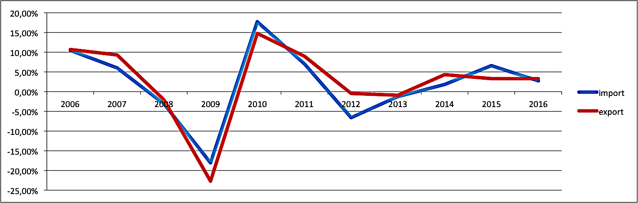

SRQ1.1: Has financial crisis affected international trade?
According to the considerations above, to answer the first sub proposition, we can say that crisis modified international trade, creating an exponential fall in import-export flows soon after 2008 and a similar, exponential rise in 2010. Trade reached pre-crisis levels in value, in a couple of years after the crisis but the very interesting thing to point out is the post-crisis very unsteady trend.

The secondo sub question attains the international trade geography. By using World and European Union data trends, we can first of all underline that import has changed differently to exports.
Import from the world and from the Union reveal two contraction phases:
- the first collapse in 2009;
- the second, during 2012-2013, and lasting the following 2014 for the world imports.
Exports reveal a very different behavior: whilst the 2009 collapse is well recognized, the following contraction only qualifies the Union flows but is not detected in the rest of the world.
This is well highlighted by the flows variation during 2016 and 2008:
Table 4: Italian international trade trend torward the European Union and the world
variation since 2008 | EXPORT | IMPORT
EU | 5,93% | 6,27%
World | 13,08% | -3,78%

Accordingly, a first, brief answer to the research question is that crisis seems to modify trade geography moving exports outside the Union, and increasing imports from the European Union Countries.
More in deep, for a comprehensive analysis of changes occurred in the international trade geography, we identify the main Italian export flows destinations. By using 2016 trade flows, and considering export as the basis to list the destinations, the following table 5 is presented.
Table 5 – Italian top destination according to 2016 export flows
2016 | EXPORT | IMPORT
FRANCE | 88.016.059.150 | 65.534.862.568
USA | 73.776.094.872 | 27.833.396.968
SPAIN | 42.107.139.960 | 39.639.574.320
SWITZERLAND | 37.931.853.860 | 21.235.344.438
GERMANY | 35.462.749.844 | 119.918.433.060
POLLAND | 22.479.183.404 | 17.581.564.814
CHINA | 22.114.373.876 | 54.691.530.220
NEEDERLANDS | 19.419.502.570 | 40.363.763.338

France is the leading destination for the Italian export flows, followed by the United States and Spain. Germany is at 5th place for export flows, but first for imports.
Comparing 2016 to 2008, a different top destinations classification emerges. Germany leads the list, followed by France.
Table 6 – Italian top destination according to 2008 export flows
2008 | EXPORT | IMPORT
GERMANY | 94.220.890.848 | 122.371.175.688
FRANCE | 82.917.909.258 | 65.745.210.580
SPAIN | 48.246.407.002 | 33.266.999.534
USA | 46.055.041.336 | 23.366.711.100
SWITZERLAND | 28.850.570.196 | 22.512.557.518
POLLAND | 19.547.569.628 | 13.416.845.650
NEEDERLANDS | 17.356.617.030 | 41.037.461.318
CHINA | 12.864.860.204 | 47.212.197.512

Figure 5 and 6 – Italian top destination according to 2016 and 2008 export flows
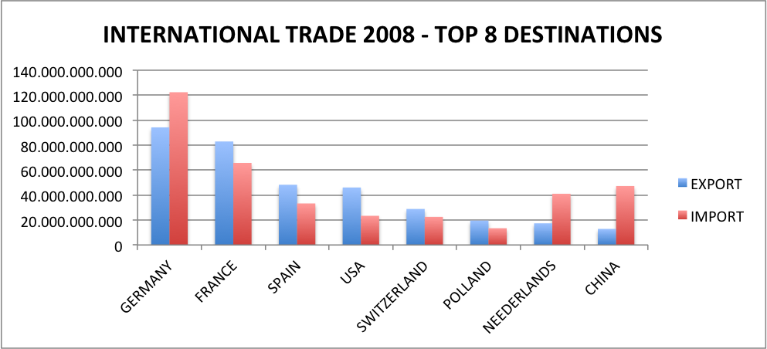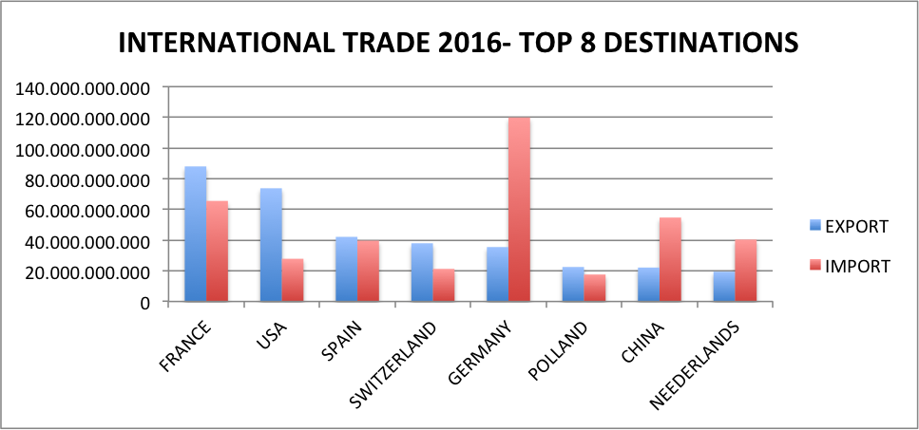
In fact, despite the international trade variations recognized for every top destination listed above, Germany is the most surprising: imports from the Country seem quite steady but exports to Germany felt down since 2008;for this reason, a deeper investigation of the import-export flows trend with Germany is due.
Table 7 – Italian trade with Germany since 2008
GERMANY | 2008 | 2009 | 2010 | 2011 | 2012 | 2013 | 2014 | 2015 | 2016
import | 122.371.175.688 | 99.401.657.984 | 117.971.054.628 | 124.776.306.814 | 110.259.401.954 | 106.598.565.370 | 108.775.283.092 | 115.182.370.434 | 119.918.433.060
export | 94.220.890.848 | 73.884.981.420 | 87.733.886.378 | 98.534.575.746 | 97.665.094.544 | 96.947.423.984 | 33.872.974.536 | 33.496.361.826 | 35.462.749.844
Figure 7 – Italian trade with Germany since 2008
As unexpected, import and export flows don’t show a collapse during the crisis: the deep reduction of 2009 is almost overcame in 2010. The very break even point is 2013: imports from Germany follow a rising trend but exports collapsed for 65% in 2014 and don’t climb up again. Table 8 resumes the annual variation in international trade flows with the Country.
Table 8 – annual variation international trade among Italy and Germany
GERMANY | 2009vs2008 | 2010vs2009 | 2011vs2010 | 2012vs2011 | 2013vs2012 | 2014vs2013 | 2015vs2014 | 2016vs2015
import | -18,77% | 18,68% | 5,77% | -11,63% | -3,32% | 2,04% | 5,89% | 4,11%
export | -21,58% | 18,74% | 12,31% | -0,88% | -0,73% | -65,06% | -1,11% | 5,87%
By using export flows of the main Italian destinations, we compare trade trends in every destination, to outline the different geography for the Italian international trade (table 9).
Table 9 – export flows to Italian top destinations
 | GERMANY | FRANCE | SPAIN | USA
2008 | 94.220.890.848 | 82.917.909.258 | 48.246.407.002 | 46.055.041.336
2009 | 73.884.981.420 | 67.968.999.564 | 33.360.119.180 | 34.198.288.950
2010 | 87.733.886.378 | 78.473.473.762 | 39.189.878.142 | 40.658.468.902
2011 | 98.534.575.746 | 87.186.689.224 | 39.780.106.332 | 45.661.758.770
2012 | 97.665.094.544 | 86.473.371.494 | 36.619.639.198 | 53.280.416.316
2013 | 96.947.423.984 | 84.577.343.210 | 34.334.538.244 | 54.093.220.560
2014 | 33.872.974.536 | 84.032.710.124 | 36.059.146.412 | 59.511.966.842
2015 | 33.496.361.826 | 85.327.276.190 | 39.523.496.822 | 71.953.344.252
2016 | 35.462.749.844 | 88.016.059.150 | 42.107.139.960 | 73.776.094.872

(follows) | SWITZERLAND | POLLAND | NEEDERLANDS | CHINA
2008 | 28.850.570.196 | 19.547.569.628 | 17.356.617.030 | 12.864.860.204
2009 | 27.125.712.676 | 15.843.081.916 | 14.222.074.600 | 13.258.447.730
2010 | 31.645.844.438 | 17.105.844.098 | 16.736.380.770 | 17.217.989.718
2011 | 41.279.519.198 | 18.836.235.144 | 18.238.216.364 | 19.991.308.212
2012 | 45.756.114.024 | 18.467.777.192 | 18.569.322.710 | 17.997.323.768
2013 | 40.772.371.042 | 18.779.130.828 | 18.147.433.224 | 19.685.917.248
2014 | 38.106.044.440 | 20.704.962.564 | 18.791.440.512 | 20.987.339.072
2015 | 38.456.008.780 | 21.801.000.744 | 19.124.943.216 | 20.825.937.302
2016 | 37.931.853.860 | 22.479.183.404 | 19.419.502.570 | 22.114.373.876
Flows analysis in the following table 10 show that the Germany export flows deep reduction (-63,7% since 2012), has been replaced by a relationship reinforcement with United States, becoming the second best destination: export rose for 38,5% since 2012 but the full rise since 2008 counts for 60,2%. Also, China trade grew: 71,9% since 2008 (+22,9% in the last four years), confirming the Country as a very relevant destination.
Besides Germany, Spain is the only Italian destination (among the top 8’s) to have export flows lower than pre-crisis levels, with a -12,7% than 2008, but trends show a rise during the last four years, when Switzerland flows decrease for 17,1%, with a total grew counting 31,5% since 2008.
Table 10 – export flows analysis. Comparing 2016 with 2012 and 2008.
EXPORT FLOWS | 2016 vs 2012 | 2016 vs 2008
GERMANY | -63,69% | -62,36%
FRANCE | 1,78% | 6,15%
SPAIN | 14,99% | -12,72%
USA | 38,47% | 60,19%
SWITZERLAND | -17,10% | 31,48%
POLLAND | 21,72% | 15,00%
NEEDERLANDS | 4,58% | 11,89%
CHINA | 22,88% | 71,90%

Thus, considering the different export trends, we can answer the second sub question:
SRQ2.2: Does the crisis modify the geography of international trade?
In fact, we can confirm that financial crisis has deeply affected international trade very fast in 2009; suddenly, data shows a get back to pre crisis amounts. So if we consider the years the most close to the crisis, it doesn’t seems to generate a relevant destination change.
But if we get on exam a wider time, some relevant changes occurred. The results are very well presented in the following figure 10: the German export flows collapse is the only surprising, deep fall, balanced by the good rise of USA trade and, in a minor degree, the god performance of France, Spain and all the other top Italian destinations.
Figure 8 – export flows to Italian top destinations
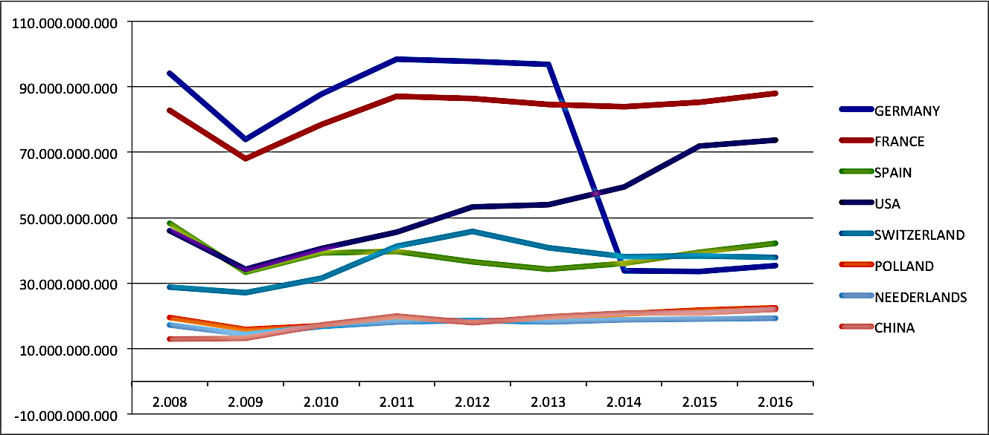

Using these results we can give full answer to the second sub question and say international trade trend became unsteady after the crisis, changing considerably export flows main destinations.
The second research proposition to be validated attains the negative relationship among 2007 crisis and failures rate: data are available in an open online platform at www.cribis.it. Cribis is a widely known research institute operating in Italy, and offering business support services and statistics. Although it is not officially devoted to publish national data, it is recognized as a relevant national data source by middle institutions and stakeholders.
The first sub question attains the failures rate. Cribis data give evidence to 2009 as the first year the crisis negative effects started to produce their effect. There is no evidence of failures data before 2009. Using Cribis failures report 2017, we resume Italian failures data since 2009, in table 1.
Table 11 – Italian failures numbers according to Cribis report 2017*
 | 2009 | 2010 | 2011 | 2012 | 2013 | 2014 | 2015 | 2016
TOTAL | 9384 | 10888 | 11840 | 12124 | 14010 | 15336 | 14585 | 13467
* www.cribis.com

Figure 9 – Italian failures numbers according to Cribis report 2017*

2014 shows the highest failures score since 2009, with a clear increase in the previous five years. Comparing 2009 and 2014 data, it is simply to calculate the failures rate:
variation since 2009 | 2014 vs. 2009
failures growth | 63%

Business failures grew during the post-crisis period, for 63%, climbing with no stops since 2009 to 2014 (table 2).
Table 12 – Failures growth rate per year in Italy
variation per year | 2010/2009 | 2011/2010 | 2012/2011 | 2013/20112 | 2014/2013 | 2015/2014 | 2016/2015
failures growth | 16% | 9% | 2% | 16% | 9% | -5% | -8%

Figure 10 – Failures growth rate per year in Italy

The next 2015 is the first year the rate shows a decrease (-5%) in years, and that seems to be a new, positive trend as it continue in 2016 (-8%).

SRQ2: Have the country businesses become strong enough to overcome the post-crisis collapse?
We state 2015 seems to be the first year of change, with a decrease in failures numbers, that continue in 2016. Following the failures rates in table 2, we want to understand if the trend inversion in the last two years lets Italy cope with failures collapse due to financial crisis.
In table 3, we checked the annual changes in failures rate since 2009. We use 2009 as the basis for every rate, to underline if the exponential increase marked in the previous tables has been overcome or not.

Table 13 – Italian failures growth compared to 2009 data
variation since 2009 | 2010/2009 | 2011/2009 | 2012/2009 | 2013/2009 | 2014/2009 | 2015/2009 | 2016/2009
failures growth | 16% | 26% | 29% | 49% | 63% | 55% | 44%

Figure 11 – Italian failures growth compared to 2009 data

In fact, data give no chance: despite the positive trend of the last two years, in 2016 failures numbers are still higher than 2009’, with a rise that exceed 40%. Yet again, the crisis continue to threat businesses existence, and markets seems not give enough support to the weakest.

Thus, to answer the first research question, we can say that Italy faced a deep economic crisis that have attached the economic equilibrium of the companies, generating an exponential growth in failures numbers. Despite a positive trend inversion in failures numbers, the Country is still so far to the pre crisis equilibrium and several businesses are still in threat.

Conclusion:
The aim of this work was to focus on a quantitative analysis of the export flows and business failures before, during and following the 2007 financial crisis, to give evidence to the existing depending links. Evaluating the changes in market shares and main Country-destinations, the paper focus was to give evidence to the effects of the 2007 crisis on Italian international attitude and geography.
Following the research hypothesis, a negative link is clearly stated among financial crisis and failures rate: data showed a rise since 2008. If it is clear that this depends on multiple factors, it also seems undoubted that such a trend depends on the negative crisis effects.
By using international trend data, it also is possible to point out the relevance of international trade in business existence: as showed in the following figure, failures rise since 2009, seems to be steady in 2011 but grow fast in 2012; at the same time, in 2012 international trade worldwide mark a negative variation, that will go on for the next 2013 and reveal a weak improvement in the following years; also, 2012 is the last year before the German export flows collapse.

Figure: Italian international trade within the world
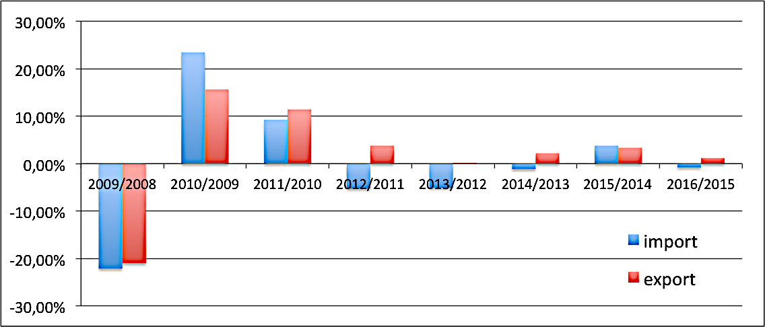
Failures rate grows in two particular years:
- 2010: as international trade collapsed for the first, deeper time;
- 2013 and 2014: as international trade collapsed for the second time; Germany is no longer the first export flows destination for the country.

Figure: faiures rate in Italy
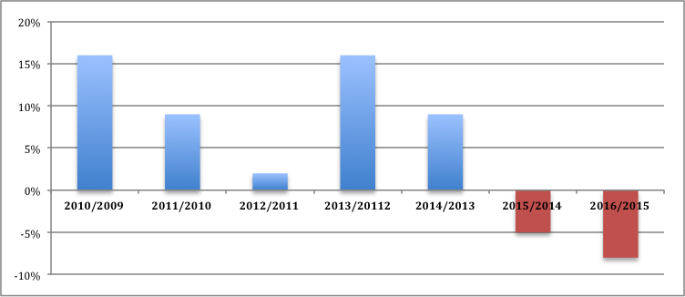

The results seem to confirm the mediated relationship among financial crisis and failures rate; also, the direct link between international trade and failures is stated, and expressed comparing timing and data trends.
This paper represents a preliminary stage of a work in progress research, aiming at identifying the direct impact of financial crisis on international attitude of Italian businesses, with a particular focus on Small and Medium Enterprises, and business response to the new environmental equilibrium.

Ansoff I., Mcdonnell E., (1990). Implanting strategic management, Upper saddle river, Perentice-Hall
Antonacopulou E.P., Sheafer Z., (2013), Learning in crisis, Rethinking the relationship between organizational learning and crisis management, Journal of Management Inquiry, 23 (1), 5-21
Brondoni S.M., (2005), Ouverture de ‘Eccesso d’offerta e mercati globali’, in Sympnonya. EMerging issues in management, www.unimib.it/symphonia.
D’Aveni H., (1994). Hypercompetition: managing the Dynamics of Strategic Maneuvering (The free press.
Emery F., Trist E., (1965), The causal texture of organizational environments, Human Relations, 18(1)12-32
Garbelli M.E., (2014). Product Differentiation Cost and Global Competition, in Symphonya, Emerging Issues in Management (www.unimib.it/symphonya), n. 1
Garbelli, M.E., (2004). Localizzazione produttiva e dinamiche competitive, Giappichelli.
Hitt, M.A., Ireland R.D., Hoskisson, R.E., (2015). Strategic Management Concepts: Competitiveness and Globalization, South-Western College Publishing, Thomson, Mason, Ohio, USA, 11e.
Hollenstein H., 2005, Determinants of International Activities: Are SMEs different?, in Small Business Economy, 24, pp. 431-450;
Lambin, JJ., Chumpitaz R., and Schuiling I, (2007). Market-driven management: Strategic and operational marketing. Palgrave Macmillan.
Mella P., Gazzola P., (2016). As the Turbulent Environment in Periods of Accelerated Dynamics Modifies Structures and Functions of Viable Firms, in Economics and Management in Urban Economy, Municipal Economy of Cities, issue 12
Mintzberg H., Gosling J., (2002), Educating Managers Beyond Borders Academy of Management Learning and Education (1, 1) — looks beyond conventional business education workers
North K., Varvakis G., (2016), Competitive strategies for Small and Medium Entreprises, Springer
Okpara J.O., Wynn P., (2007) "Human resource management practices in a transition economy: Challenges and prospects", Management Research News, Vol. 31 Issue: 1, pp.57-76,
Raymond L., Josée St-Pierre J., Uwizeyemungu S., Le Dinh T., (2014), Internazionalization Capabilities of SMEs: A Comparative Study of Manufacturing and Industrial Service Sectors, in Journal of International Entrepreneurship, 12, pp, 230-253.
Stigter, H., (2002) Co-operation as a response to a turbulent environment. EIM Business and Policy Research, 1-40
Ganotakis, P. & James, H.L. (2012) Export propensity, export intensity and firm performance: the role of the entrepreneurial founding team. Journal of International Business Studies. 43, pp. 693-718.
Maurel, C. (2009) Determinants of export performance in French wine SMEs. International Journal of Wine Business Research. 21(2), pp. 118-142.
Enderwick, P. (2009) Responding to global crisis: The contribution of emerging markets to strategic adaptation. International Journal of Emerging Markets. 4(4), pp. 358–374
Cavusgil, S.T, John R.N., (1981) Internal determinants of export marketing behavior: An empirical investigation. Journal of Marketing Research. 18 (1), pp. 309–312.
Katsikea, E.S. & Skarmeas, D.A. (2003) Organisational and managerial drivers of effective export sales organizations. European Journal of Marketing. 37(11/12), pp. 1723-1745.
Bhanu Murthy K.V., Kalsie A., (2013), Measurement of International Currency Crises: A Panel Data Approach using Composite Indices, VIkalpa, 38 (4), pp.13-36.
Zou, S., & Stan, S. (1998). The determinants of export performance: a review of the empirical literature between 1987 and 1997. International Marketing Review, 15(5), 333-356. doi: 10.1108/02651339810236290
Welch, L., & Luostarinen, R. (1988). Internationalization: evolution of a concept. Journal of General Management, 14(2), 34-55.
Styles, C. A (1998). Cross-cultural examination of export performance. Journal of International Marketing, 6(3), 5-31.
Shoham, A. (1998). Export performance: a conceptualization and empirical assessment. Journal of International Marketing, 6(3), 59-81.
Katsikeas, C., Leonidou, L., & Morgan, N. (2000). Firm-level export performance assessment: review, evaluation and development. Academy of Marketing Science, 28(4), 493-511. doi: 10.1177/0092070300284003
Johanson, J. & Vahlne, J.-E. (1977). The internationalization process of the firm: a model of knowledge and increasing foreign market commitment. Journal of International Business Studies, 8(1), 23-32. doi:10.1057/palgrave.jibs.8490676
Moini, A. (1995). An inquiry into successful exporting: an empirical investigation using a three-stage model. Journal of Small Business Management, 33(3), 9-25.
Madsen, T. (1998). Managerial judgment of export performance. Journal of International Marketing, 6(3), 82-93.
Leonidou, L., Katsikeas, C., & Samiee, S. (2002). Marketing strategy determinants of export performance: a meta-analysis. Journal of Business Research, 55(1), 51-67. doi: 10.1016/S0148- 2963(00)00133-8
Sousa, C., Martınez-Lopez, F. J., & Coelho, F. (2008). The determinants of export performance: A review of the research in the literature between 1998 and 2005. International Journal of Management Reviews, 10(2), 1–32.
Carramazza, F., Ricci, L., & Salgado, R. (2000). Trade and fi- nancial contagion in currency crises. IMF WP 00/55, March. Accessed through www.imf.org
Spector, P. E. (1992). Summated rating scale construction: An introduction. California: Sage University.
Golovko, E., & Valentini, G. (2011). Exploring the complementarity between innovation and export for SMEs growth. Journal of International Business Studies, 42, 362–380.
Yu, Y. and Lindsay, V. (2016). Export Commitment and the Global Financial Crisis: Perspectives from the New Zealand Wine Industry. Journal of Small Business Management, 54: 771–797. doi:10.1111/jsbm.12171
Johanson, J., & Vahlne, J. E. (2009). The Uppsala internationalization process model revisited: From liability of foreignness to liability of outsidership. Journal of International Business Studies, 40(9), 1411–1431.
Johnston, W. J., & Czinkota, M. R. (1982). Managerial motivations as determinants of industrial export behavior. In M. R. Czinkota & G. Tesar (Eds.), Export management: An international context. New York, NY: Praeger.
Lages, L. F., Silva, G., & Styles, C. (2009). Relationship capabilities, quality, and innovation as determinants of export performance. Journal of International Marketing, 17(4), 47–70.
Stoian, M. C., Rialp, A., & Rialp, J. (2011). Export performance under the microscope: A glance through Spanish lenses. International Business Review, 20(2), 117–135.
Teece, D. J. (2007). Explicating dynamic capabilities: the nature and microfoundations of (sustainable) enterprise performance. Strategic management journal, 28(13), 1319–1350.

