ENHANCED BRAIN TARGETING OF ENGINEERED SOLID LIPID NANOPARTICLES

R. Dal Magro¹, F. Ornaghi¹, I. Cambianica¹, S. Beretta¹, F. Re¹, A. Brambilla¹, F. Barbero², C. Musicanti², A. Cagnotto³, E. Donzelli⁴, A. Canta⁴, M. Masserini¹, G. Cavaletti⁴, P. Gasco², G. Sancini¹

¹ Department of Health Sciences, University of Milano-Bicocca, via Cadore 48, 20900 Monza, MB, Italy.
² Nanovector S.r.l., via Livorno, 60 - 10144 Torino, TO, Italy.
³ Department of Molecular Biochemistry and Pharmacology, Mario Negri Institute for Pharmacological Research, via La Masa 19, 20156 Milano, MI, Italy.
⁴ Department of Surgery and Translational Medicine, University of Milano-Bicocca, via Cadore 48, 20900 Monza, MB, Italy.

Introduction
The blood-brain barrier (BBB) plays an important role in maintaining the homeostasis of the central nervous system and in protecting the brain from potentially harmful endogenous and exogenous compounds. Nevertheless it represents also the major obstacle for the diagnosis and therapy of brain diseases. One of the most promising strategies to overcome the limited BBB penetration of drugs and contrast agents is based on nanoparticles (NP). Lipid based NP, basically liposomes and solid lipid nanoparticles (SLN), have several advantages in terms of biocompatibility, non-immunogenicity, non-toxicity; they can be used as carrier systems [1], and they have a high blood circulation residence time [2]. Moreover their surface can be easily modified with ligands which mediate a site-specific targeting.

Goal of the work
The objective of present investigation was to study the effect of surface characteristics of SLN covalently coupled with the monomer of ApoE-residues (141-150) (mApoE-SLN) in promoting BBB crossing and brain targeting using both in vitro and in vivo models.

Methods
Radiolabelled or fluorescent dye-loaded SLN, covalently coupled by DSPE-PEG(2000)-Maleimide with the monomer of ApoE-residues (141-150) [3] and functionalized with phosphatidic acid (Aβ ligands) [4], were used in the present work and produced by Nanovector s.r.l. (Torino, Italy). In vitro evaluations were performed using cultured human cerebral microvascular endothelial cells (hCMEC/D3) obtained from Institute Cochin (INSERM, Paris, France). SLN cell uptake was monitored by confocal-laser-scanning microscopy and cell-associated fluorescence was quantified by FACS analysis. Radiochemical technique was used in order to assess the ability of ApoE monomer to enhance SLN transcellular transport across the hCMEC/D3 BBB model [5]. The in vivo biodistribution of SLN, loaded with DiR (near-infrared fluorescent cyanine dye), was evaluated by means of Fluorescent Microscopy Tomography (FMT 1500, Perkin Elmer). BALB/c male mice were intravenous (IV), intratracheal (IT) or intraperitoneal (IP) administered with 50 ul of SLN formulation and tomographic data analyses were achieved using the TrueQuant software supplied (Perkin Elmer). The total amount (in picomoles) of fluorophore in the brain region was calculated by the provided software using previously generated standards of the appropriate dye [6].

Results and Discussion
We demonstrated that surface functionalization of SLN with ApoE monomer plays a major role in promoting their cellular uptake within hCMEC/D3. Cell associated fluorescence was about two-fold higher in presence of SLN-mApoE compared to unfunctionalized SLN (SLN-cys) and the same trend was observed by CLSM analysis. The ability of SLN to cross the in vitro hCMEC/D3 BBB model was assessed using dual-radiolabelled formulations. With respect to SLN-cys, the presence of monomer ApoE significantly enhanced their permeability through the cell monolayer; moreover PE values obtained with the two radiotracers were equivalent for the same SLN formulation, and about 6-fold higher for SLN-mApoE (Fig. 1). These results suggest that, at least at the dose tested, SLN cross intact the cell monolayer.

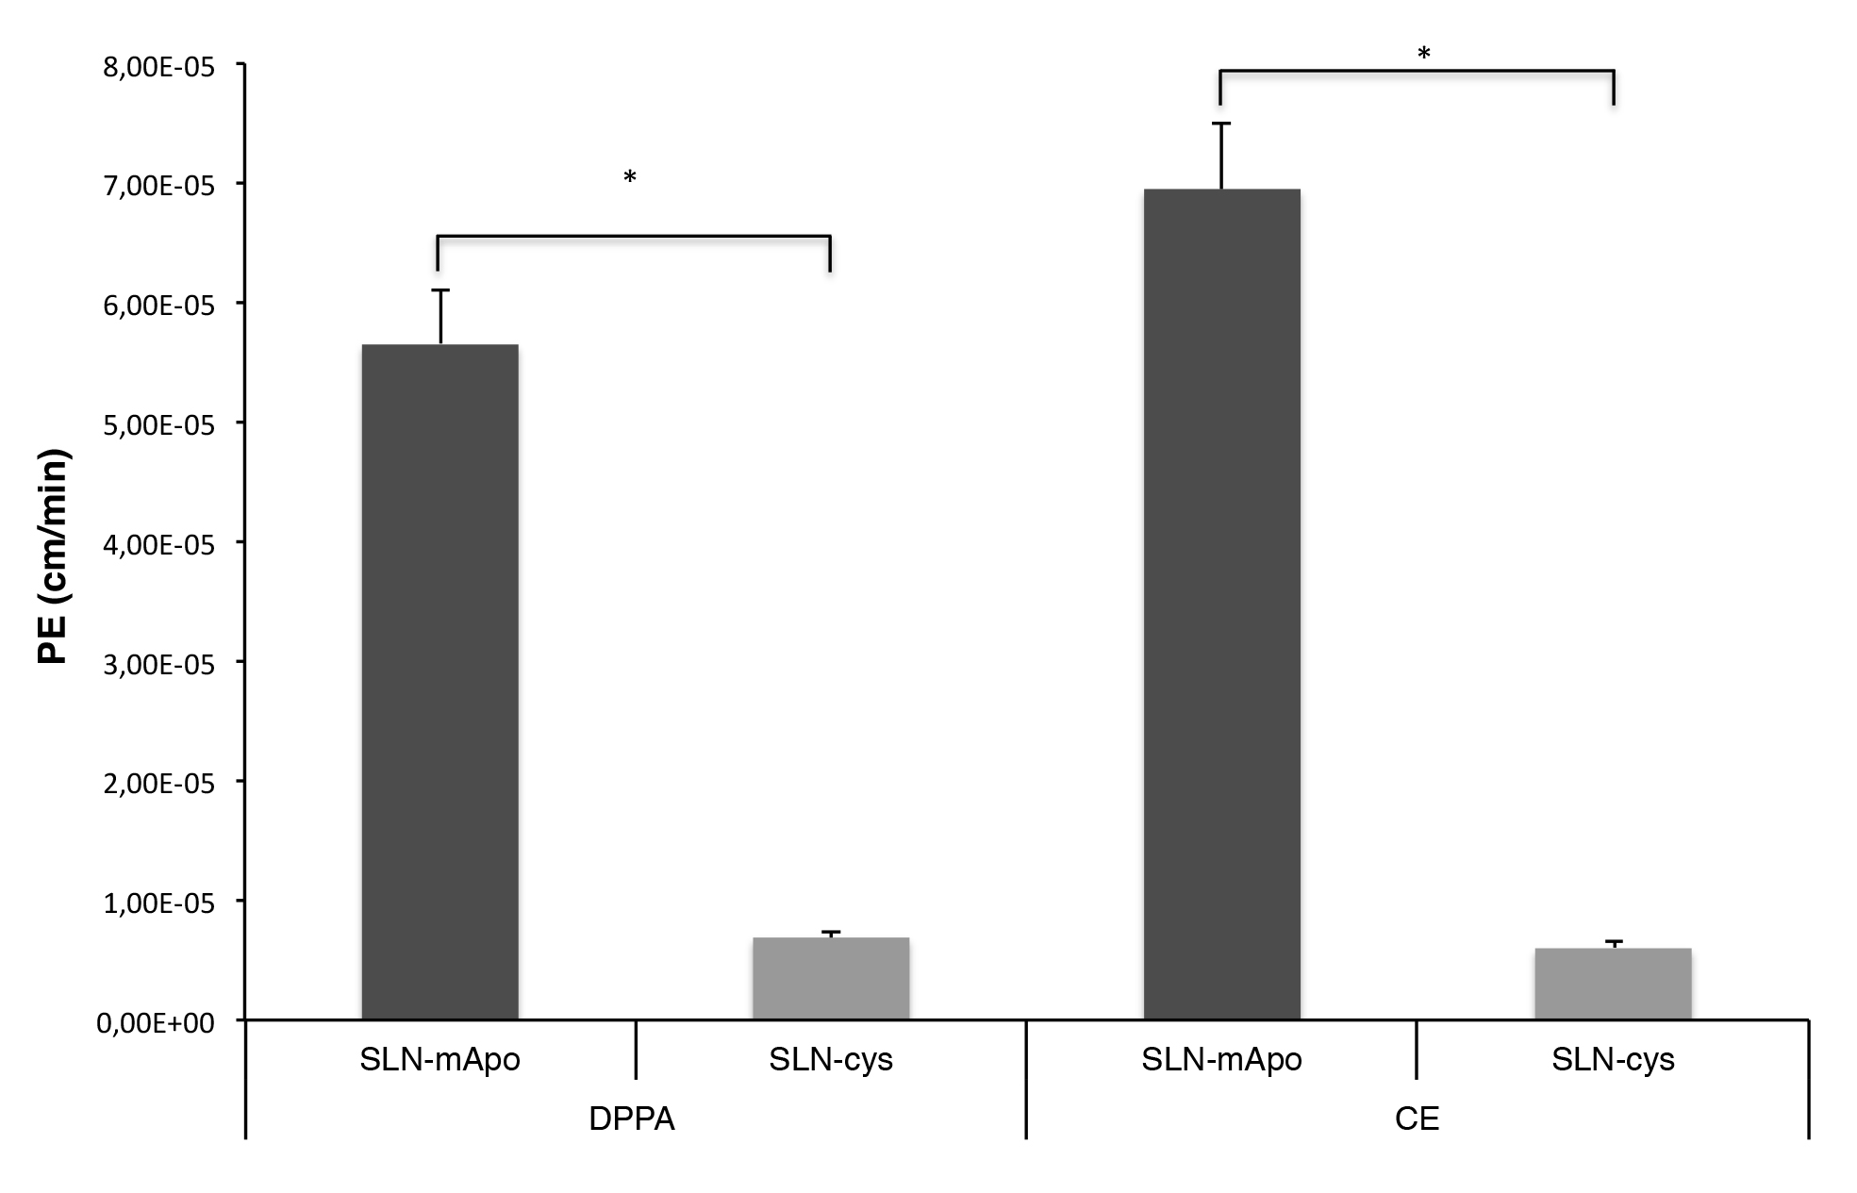
Fig.1 Transport of dual-radiolabelled SLN across hCMEC/D3 monolayer (*= p<0,01)

In vivo results confirmed the role of monomer ApoE in sustaining the delivery of SLN to the central nervous system. In particular we demonstrated that, compared to the most common routes for drug administration (IP and IV injections), IT instillation represents the best method to guarantee the biodistribution of SLN-mApoE in the brain district and to favour their retention up to 24 hours after the administration (Fig. 2).

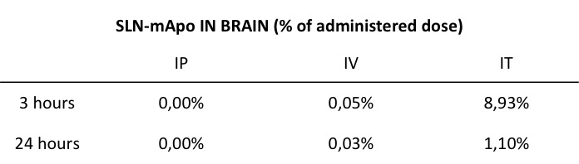

Fig. 2 Per cent of SLN-mApo in brain after IP, IV or IT administration

Bronchoalveolar lavage fluid (BALF) analysis does not evidence any pro-inflammatory reaction in lungs of SLN-mApoE IT-treated mice with no alteration of the alveolar-capillary barrier permeability.

Conclusions
The results here obtained suggest that the SLN formulation herein analysed could represent a suitable tool for sustaining drug delivery to the brain.

References
1. Priano L et al, Eur J Pharm Biopharm 79 (2011)
2. Gasco MR et al, Prog Brain Res 180 (2009)
3. Re F et al, Nanomedicine 7 (2011)
4. Gobbi M et al, Biomaterials 31 (2010)
5. Re F et al, J Biotechnol 156 (2010)
6. Tsurumi C et al, PLoS One 12 (2010)

