Nanoscale ductility in c-plane Al₂O₃: Dislocation and twinning mechanisms via nanoindentation and molecular dynamics
Qinqin Xuª, Ibrahim Goda^{b}, Agata Zaborowska^{a,**}, Katarzyna Mulewskaª, Witold Chrominski^{a,c}, Damian Kalitaª, Łukasz Kurpaskaª, Claudio Fusco^{d}, Fabrizio Rovaris^{e}, Wenyi Huo ^{a,f,*}
- NOMATEN Centre of Excellence, National Centre for Nuclear Research, Otwock 05-400, Poland
- LEM3, Arts et Métiers Paris Tech, Université de Lorraine, CNRS, Metz 57073, France
- Faculty of Materials Science and Engineering, Warsaw University of Technology, Warsaw 02-507, Poland
- Univ Lyon, INSA Lyon, CNRS, MATEIS UMR5510, Villeurbanne 69621, France
- Department of Materials Science, University of Milano-Bicocca, Milano 20125, Italy
- College of Mechanical and Electrical Engineering, Nanjing Forestry University, Nanjing 210037, China
*Corresponding author: Wenyi Huo. E-mail: wenyi.huo@ncbj.gov.pl. Address: NOMATEN Centre of Excellence, National Centre for Nuclear Research, Otwock, Poland.
**Corresponding author: Agata Zaborowska. E-mail: agata.zaborowska@ncbj.gov.pl.

Abstract:
Brittle oxides, such as α-Al₂O₃, i.e., sapphire, are traditionally unsuitable for ductile applications, yet exhibit enhanced plasticity at nanoscale. This study explores the mechanical behavior of c-plane-oriented, dislocation-free monocrystalline α-Al₂O₃ via molecular dynamics (MD) simulations and experiments, including nanoindentation and post-indentation TEM analysis. The results demonstrate high strength with homogeneous, extensive deformation without failure. Plasticity is dominated by basal (0001) dislocations and rhombohedral [10$\overline{1}$1] twins, which nucleate at deformation onset, as confirmed by MD and TEM. Generalized stacking fault energy (GSFE) and twinning fault energy (TFE) calculations elucidate mechanisms that mitigate crack initiation and propagation on the c-plane, aligning simulations with observations. These insights advance the understanding of nanoscale ductility in oxides, broadening the utility of sapphire in load-bearing micro/nano devices.
Keywords: α-Al₂O₃, Nanoindentation, Molecular dynamics, Dislocations
1. Introduction
Monocrystalline sapphire (α-Al₂O₃) exhibits exceptional mechanical, physical, and electrochemical properties, making it a material of significant interest for various applications [1-3]. Its high hardness, chemical stability, and optical transparency have led to its widespread use in optical components, semiconductor equipment, and protective coatings [4]. Despite its inherent brittleness, α-Al₂O₃ has been shown to undergo plastic deformation under certain conditions, as evidenced by indentation and abrasion studies analyzed using transmission electron microscopy (TEM) at room temperature (RT) [5-6]. The primary mechanisms driving this plasticity are dislocation slip and twinning, which enable localized deformation without catastrophic failure. However, compared to ductile metal alloys, metal oxides such as α-Al₂O₃ are typically considered brittle because of their susceptibility to crack initiation and propagation under localized stresses [7]. This brittleness is particularly pronounced at larger scales, where stress concentrations can lead to rapid fracture. At the nanoscale, however, recent studies suggest that localized plasticity mechanisms can suppress crack propagation by redistributing stress through dislocation and twinning activity [8].
Understanding the deformation mechanisms of sapphire at small scales, such as the nanoscale, is crucial for explaining the processes governing crack initiation and growth. Nanoindentation, a technique widely used to probe mechanical properties at very small scales, has revealed that stress effects are even more pronounced under such conditions, providing insights into the behavior of materials under extreme localized loading [9, 10]. These findings not only are fundamental to advancing the understanding of α-Al₂O₃ but also have practical implications for its use in advanced applications, such as micro-electromechanical systems and high-performance coatings, where mechanical reliability at small scales is critical.
Owing to the small scale of the observed objects, in situ mechanical tests performed via TEM/scanning electron microscopy (SEM) have provided valuable insights into deformation mechanisms at the micro- and nanoscale [11, 12]. These techniques enable real-time observation of material behavior under stress, revealing details such as dislocation dynamics, crack initiation, and twinning processes. However, the majority of such studies have focused on metals, particularly face-centered cubic (FCC) materials such as copper and gold, due to their well-defined plasticity and ease of experimentation [13-15]. In contrast, ceramics, which are inherently more brittle and challenging to study at small scales, have received comparatively less attention [16-19]. For example, Calvie et al. demonstrated that small alumina nanoparticles (<100 nm) exhibit unexpected ductility under compression, with no signs of cracking even at high strains [20]. The authors developed a novel methodology to determine the constitutive laws of these nanoparticles via in situ TEM compression tests combined with digital image correlation. By analyzing force-displacement curves, they extracted constitutive parameters via two approaches: the Hertz theory for the elastic response during loading and a cylindrical model for the unloading curve. Interestingly, for larger particles (>100 nm), the mechanical behavior transitioned to that of the bulk material, displaying brittle characteristics with crack propagation occurring within the elastic regime. These larger particles exhibited a maximum compressive strength of 3.4 GPa, highlighting the size-dependent mechanical properties of alumina. Further insights into deformation mechanisms in ceramics have been provided by other studies. Tromas et al. [21] used atomic force microscopy (AFM) to observe individual slip lines along the <100> direction in MgO crystals, allowing quantification of the number of dislocations involved in the slip process. Lagerlöf et al. [22] conducted TEM experiments to examine dislocation slip and twinning in α-Al₂O₃, confirming prismatic a and m slips at temperatures as low as 200°C for compression along the c-axis. They also observed more complex deformation processes, including basal and rhombohedral twinning, at temperatures down to 400°C for compression axes oriented 45° from < >. These findings highlight the complexity of deformation mechanisms in ceramics and their sensitivity to crystallographic orientation and temperature. Building on these insights, this work aims to further investigate the mechanical behavior of monocrystalline sapphire via a combination of MD simulations and post-indentation TEM analysis. MD simulations have proven to be a powerful tool for revealing deformation mechanisms, particularly dislocation-related activity, at the atomic scale [23]. For instance, Tsuruta et al. developed a local atomic model for basal edge and partial dislocations in α-Al₂O₃, which aligns well with experimental TEM observations [24]. Similarly, Lin et al. studied the deformation mechanisms of c-oriented sapphire during scratching via both MD simulations and experiments, demonstrating how crystal structure influences mechanical behavior [25]. These studies highlight the importance of crystallographic orientation, as preferentially oriented α-Al₂O₃ samples exhibit superior mechanical properties compared with their non-textured counterparts [26].
However, the atomic-scale deformation mechanisms of α-Al₂O₃ under nanoindentation, particularly for specific orientations, remain insufficiently explored. Numerous nanoindentation studies have investigated the deformation behavior and mechanical properties of single-crystal alumina [25, 27-33]. For instance, Mao et al. [30, 31] found that variations in the indenter radius and loading rates significantly affected nanoscale pop-in phenomena during indentation using Berkovich indenters. They explained that the first pop-in event corresponds to dislocation nucleation, as interpreted through Hertzian contact theory and an energy-based approach. However, their studies primarily focused on the initial stages of elastic–plastic deformation and did not provide a detailed analysis of subsequent dislocation activity. Additionally, Trabadelo et al. [32] studied the effects of different crystallographic orientations on the plastic deformation and cracking of sapphire using spherical nanoindentation. Their study revealed that the elementary deformation processes varied depending on the indenter radius and applied stress. Specifically, twin dislocations were observed with smaller-radius indenters (1 and 2 μm), while both twinning and crack propagation were evident for a larger-radius indenter (10 μm). These results significantly contributed to the understanding of deformation and cracking behavior in sapphire under spherical SEM and TEM nanoindentation. However, a detailed analysis of the twinning dislocation or slip system is lacking. Moreover, Lin et al. [25] conducted nanoscratching experiments and compared the results with those of MD simulations to explore the deformation mechanisms of c-plane sapphires. High-resolution TEM (HRTEM) images revealed basal slip/twinning and rhombohedral slip in the damaged areas. However, discrepancies between the experimental and MD simulation results were attributed to limitations in the Matsui interatomic force field used in the simulations [34].
In this study, we present the results of post-indentation TEM analysis and MD simulations of monocrystalline sapphire on the c (0001) plane at RT. The MD simulations are designed to investigate deformation mechanisms at the atomic scale, while the experimental results provide validation and support for the simulation findings. By combining these approaches, this work provides a comprehensive understanding of the deformation behavior of sapphire under localized loading. Furthermore, the observed dominance of basal dislocations and rhombohedral twinning provides direct insight into the deformation mechanisms in α-Al₂O₃. These deformation processes dissipate local stress concentrations under indentation, thereby delaying crack initiation and promoting nanoscale ductility. This work provides two key contributions beyond previous investigations on sapphire deformation mechanisms. (1) Correlation of experimental TEM observations and MD simulations to identify the dominant deformation mechanisms, specifically basal slip and rhombohedral twinning under c-plane indentation. (2) A mechanistic interpretation is established on the basis of generalized stacking fault energy (GSFE) and twin fault energy (TFE) analyses, which reveal the relative energy barriers of basal and rhombohedral systems and explain the experimentally observed deformation sequence. Overall, this combined experimental-computational approach clarifies how crystallographic orientation, stress localization, and fault energy hierarchy collectively govern plasticity in α-Al₂O₃.
2. Computational and experimental methods
2.1. Experimental methods
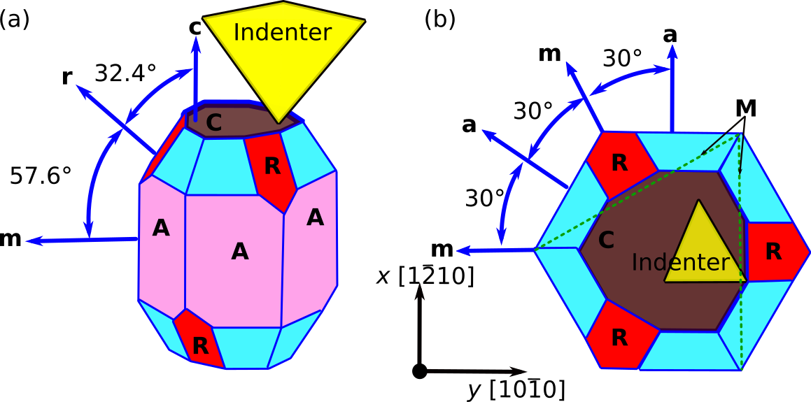
Fig. 1 Crystal structure of single-crystal sapphire.

c-Plane sapphire monocrystals were used as the workpiece material to investigate the anisotropic characteristics of material deformation normal to the c-plane (0001). Sapphire substrates were procured from Helios New Materials Limited (China) in the form of squares with a thickness of 0.43 mm and a surface roughness below 0.3 nm. The samples were subjected to chemical and fine manual polishing procedures to ensure a pristine surface for nanoindentation studies. Nanoindentation experiments were conducted using a NanoTest Vantage System (Micro Materials Ltd., MML) equipped with a diamond Berkovich indenter. All measurements were performed at room temperature in load-controlled mode, with a maximum load of 50 mN. Each indentation was repeated 15 times, with an interval spacing of 50 µm between indentations to avoid interaction effects. A single indentation cycle consisted of loading at a rate of 0.5 mN/s, a 3 s dwell period at maximum load, and unloading at the same rate of 0.5 mN/s. The hardness and reduced Young’s modulus (E_{r}) were assessed from the unloading curve using the Oliver and Pharr method [35]. To convert the reduced Young’s modulus to the actual Young’s modulus, a Poisson’s ratio of 0.29 [36] was used. For TEM analysis, cross-sectional samples were prepared from the indented regions using a focused ion beam (FIB) technique. A dual-beam Thermo Fisher Scientific Helios 5 UX scanning electron microscope (SEM) was employed for this purpose. To minimize Ga implantation during FIB milling, the final thinning step was performed using a low-energy 2 keV Ga+ beam. The TEM observations focused on the deformed cross-section beneath the indentations, providing insights into the subsurface damage and deformation mechanisms. The crystallographic orientation of the sapphire samples is illustrated in Fig. 1. Monocrystalline sapphire exhibits four primary crystal plane orientations: the prismatic a plane [ ], the prismatic m plane [], the basal c plane (0001), and the rhombohedral R plane [ ]. From the top view, the c plane is normal to the a and m planes, while the angle between the R plane and the c plane is 57.6° [37]. The Berkovich indenter was aligned normal to the c plane for all experiments.
2.2 Computational methods
MD simulations were performed to investigate the elementary deformation mechanisms of single-crystal α-Al₂O₃ under Berkovich nanoindentation at RT. The simulations were conducted using the open-source LAMMPS code [38], with atomic interactions described by a 2/3-body interatomic potential. This potential has been validated for accurately reproducing nanomechanical properties such as lattice parameters, surface and stacking fault energies, and dislocation nucleation under nanocompression [39]. A cutoff parameter of 6 Å was used for short-range interactions.
The simulation model consisted of an α-Al₂O₃ substrate with dimensions of approximately 35.0 nm × 33.6 nm × 32.6 nm, containing approximately 3.3 × 10⁶ atoms. The lattice parameters, a = 4.274 Å and c = 14.17 Å, were determined from experimental data and first-principles simulations [40, 41]. The indentation process was simulated using the following procedure: First, the substrate was energy-minimized using a conjugate gradient algorithm followed by the FIRE algorithm [42]. The system was then equilibrated for 50 ps in the NVT ensemble at 300 K using a Nosé-Hoover thermostat [43].
The boundary conditions were carefully selected to ensure realistic deformation behavior. As shown in Fig. 2, periodic boundary conditions were applied in the X [] and Y [] directions, while the Z-direction (normal to the c plane) was set with a fixed boundary condition. The initial configuration was a fully relaxed, defect-free α-Al₂O₃ crystal to ensure that all dislocations and twin structures observed during indentation were nucleated in response to the applied stress, without pre-existing defects. This approach isolates the intrinsic nucleation mechanisms. The substrate was divided into three layers: a fixed layer at the bottom to prevent rigid body motion, a thermostat layer to dissipate excess heat [44], and a Newtonian layer where atoms followed Newton’s second law of motion. The Berkovich indenter was modeled as a rigid body, and indentation was performed at a velocity of 100 m/s with a time step of 1 fs. The nanomechanical response of the sample was analyzed using the Hertz contact model, where the force-depth relationship is given by:
F(δ) = 4/3 E*R^{1/2} δ^{3/2} (1),
where is the effective Young’s modulus, R is the indenter radius, and δ is the indentation depth. To analyze the deformation mechanisms, atomic-scale structures were visualized using OVITO [45-47]. The evolution of dislocations and twin structures was assessed using dislocation extraction algorithms and stacking fault energy calculations. In addition, the Lee and Lagerlöf orientation table was used to verify the angles θ between low-index crystalline planes in α-Al₂O₃ (e.g., the angle between the loading orientation and possible slip planes) [48].
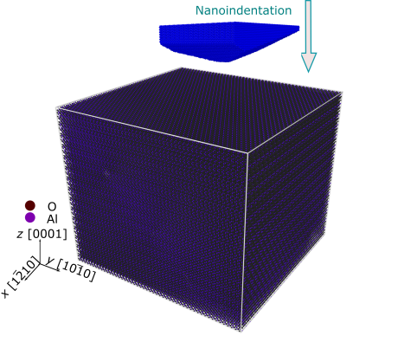
Fig. 2. Schematic diagram of the indentation MD simulation model and an α-Al₂O₃ sample.
3. Results and discussion
In this section, we present the experimental and computational findings related to the nanoindentation of monocrystalline sapphire on the c (0001) plane. By comparing the load-displacement curves obtained from nanoindentation experiments and MD simulations, we analyze the elastic-plastic response and deformation mechanisms. Additionally, we explore the nucleation and evolution of dislocations and stacking faults (SFs) through TEM and MD simulations. The results provide insights into the dominant deformation mechanisms, including basal slip and rhombohedral twinning, and their implications for the mechanical behavior of sapphire under localized loading.
To ensure clarity, the deformation mechanisms discussed in this section follow the conventional crystallographic terminology for α-Al₂O₃. Basal slip refers to dislocation motion on the (0001) plane along the direction, typically involving partial dislocations that bound stacking faults. Rhombohedral twinning and basal twinning denote twinning on the [10$\overline{1}$1] and (0001) planes, respectively. The term rhombohedral slip is used here to describe limited shear along the [10$\overline{1}$1] plane. Partial dislocations correspond to Shockley-type dislocations that terminate stacking faults, whereas edge dislocations refer to full dislocations with Burgers vectors lying within the basal plane. This terminology is adopted consistently throughout the manuscript to distinguish between the observed and simulated deformation modes.

3.1 Load-displacement curves of indentation on c-plane sapphire
The load-displacement curves obtained from both experimental nanoindentation and MD simulations are presented in Fig. 3. These curves provide crucial insights into the elastic-plastic transition and deformation behavior of α-Al₂O₃ under localized loading. Fig. 3(a) illustrates the experimental load-displacement curve for nanoindentation on the c plane (0001) of α-Al₂O₃ at a loading rate of ν = 0.5 mN/s. The curve clearly shows pop-in events, which are associated with the nucleation and propagation of dislocations. These first pop-in events were reproducible across multiple indentations (n = 15), indicating consistent onset of plasticity. The hardness and Young’s modulus calculated from the unloading curve are 26.7 ± 2.0 GPa and 315 ± 8 GPa, respectively (n = 15). These values are consistent with previously reported results for crystalline alumina [49–53], validating the reliability of our experimental setup.
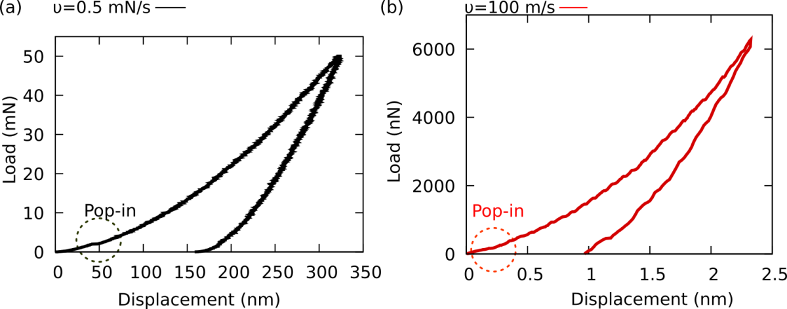
Fig. 3 Load vs. depth curves from experimental nanoindentation and MD simulations. The elastic-plastic transition region is marked with a circle (pop-in). (a) Experimental load-displacement curve for α-Al₂O₃ indented normal to the c-plane (0001) at a loading rate of ν = 0.5 mN/s. (b) Simulated load-displacement curve from MD simulations at a loading rate of ν = 100 m/s.

To complement the experimental findings, MD simulations were performed at a significantly higher loading rate of 100 m/s as shown in Fig. 3(b). Despite the differences in loading rates and sample sizes, MD simulations provide valuable qualitative insights into nanoscale deformation mechanisms [54-56]. The simulated load-displacement curve fluctuates during loading, which can be attributed to the limited relaxation time for atomic rearrangements under high strain rates. The Young’s modulus derived from the MD simulations (319.6 GPa) closely matches the experimental value (315 ± 8 GPa), further validating the computational approach.
While the experimental and simulated loading rates differ by several orders of magnitude, the comparison remains meaningful for understanding the deformation mechanisms in α-Al₂O₃. The higher loading rate in MD simulations is a practical necessity due to computational limitations, as simulating slower loading rates would require prohibitively long simulation times. Nevertheless, the qualitative agreement between the experimental and simulated curves suggests that the MD simulations capture the essential features of the deformation process, including the elastic-plastic transition and the role of pop-in events.
The fluctuations observed in the MD load-displacement curve (Fig. 3(b)) can be attributed to the limited relaxation time for atomic rearrangements under high strain rates [57, 58]. At the experimental loading rate (ν = 0.5 mN/s), the material has more time to accommodate the applied stress through dislocation glide and other mechanisms, resulting in a smoother load-displacement curve. In contrast, the higher loading rate in the simulations (ν = 100 m/s) leads to a more abrupt response, as the atoms have less time to adjust to the applied load. To clarify the MD results, pop-in events in the simulations are identified as sudden increases in displacement under approximately constant load, following the same qualitative criteria as in the experiments. While the high indentation rate and limited cell size in MD induce fluctuations and obscure sharp pop-in markers, the simulations still capture the elastic–plastic transition and the sequence of dislocation nucleation and twinning events. Therefore, the MD results provide mechanistic insight into plasticity rather than precise quantitative equivalence with experimental pop-in loads.
Despite these differences, the comparison provides valuable insights into the deformation mechanisms in α-Al₂O₃. The presence of pop-in events in both curves indicates that the transition from elastic deformation to plastic deformation is a fundamental feature of the response of α-Al₂O₃ to localized loading, regardless of the loading rate. This interpretation aligns with previous studies on the deformation of brittle materials, which have shown that pop-in events are associated with the nucleation and propagation of dislocations [59–61]. The pop-in events observed in both experimental and simulated curves mark the onset of plastic deformation. These events are associated with the nucleation and propagation of dislocations, as well as the formation of stacking faults and twins.
This behavior corresponds to the brittle-to-ductile transition (BDT) in α-Al₂O₃, which is strongly dependent on the deformation scale, temperature, and crystal orientation. For instance, Montagne et al. [59] observed a BDT in α-Al₂O₃ pillars during in situ SEM microcompression experiments, where dislocation glide was favored over cracking. Similarly, Zhang et al. [60] highlighted the influence of deformation scale and temperature on the BDT, while Wang et al. [61] developed a mechanical model to predict the critical loads for pop-in events in α-Al₂O₃, incorporating factors such as crystal orientation and applied stress, which are crucial for determining the initiation of plastic deformation. In our experiments and simulations, the nanoscale contact, room temperature, and c-plane orientation collectively enable basal dislocations and rhombohedral twins to nucleate, as shown in Fig. 4, illustrating the BDT under the specific conditions studied.
Fig. 4 illustrates several dislocations that emerge, including: (a) atomic phase transitions grouped with hexagonal close-packed (HCP), body-centered cubic (BCC) and FCC structures, which act as locking points for further dislocation nucleation during nanoindentation. (b) Under the amorphous surface, an obvious strain is constructed by dislocation shearing, and the basal partial dislocation configuration is blocked under the indenter. (c) Promotion of the basal nucleation of dislocations is initiated from pre-parts, and the rhombohedral twins emanate from the edge of the plastic zone. In the last several sub-figures (d)-(e), the plastic deformed zone and rhombohedral twins are imposed by a driving indenter force on the growing dislocation microstructures.
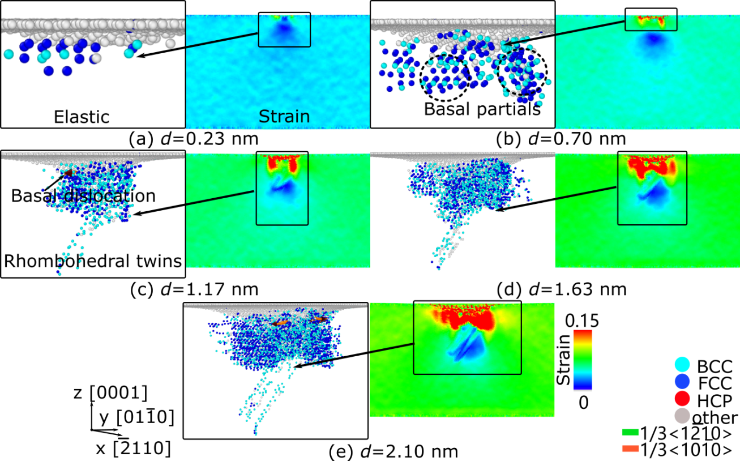
Fig. 4 MD simulation images and von Mises strain of α-Al₂O₃ sample during nanoindentation. (a) Elastic deformation and phase transition at depth d= 0.23 nm. (b)-(e) Dislocation evolution of the sample during plastic deformation.
3.2 Dislocation nucleation in sapphire
Fig. 5 presents a detailed comparison of dislocation nucleation and twin formation in α-Al₂O₃, as observed through scanning transmission electron microscopy (STEM) and MD simulations. Fig. 5(a) shows STEM images of the cross-section beneath the indented c-plane (0001) surface at RT. The observed dislocations are marked with dashed lines, with black lines indicating dislocations parallel to the indented surface and red lines showing defects inclined at approximately 57.6° relative to the indented surface. The inclination of these defects suggests a preferential nucleation mechanism that governs plastic deformation in sapphire under indentation stress. In Fig. 5(b), the MD simulation results at a maximum indentation depth of δ = 2.0 nm and a loading velocity of ν = 100 m/s illustrate the defect evolution distribution. The atomic-scale deformation mechanisms are further examined in Fig. 5(c), which reveals basal slip along the c (0001) plane, oriented perpendicular to the c-plane. This finding indicates that basal dislocations are among the primary defects formed in response to indentation. Fig. 5(d) provides a magnified view of the basal dislocations, illustrating stacking faults (SFs) composed of FCC-structured atoms, which facilitate the deformation process. As shown in Fig. 5(e), further magnification reveals both the SFs and the formation of rhombohedral twins , with dislocations associated with twinning. The twinning dislocations are confirmed via the fast Fourier transform (FFT) analysis of the HRTEM images.
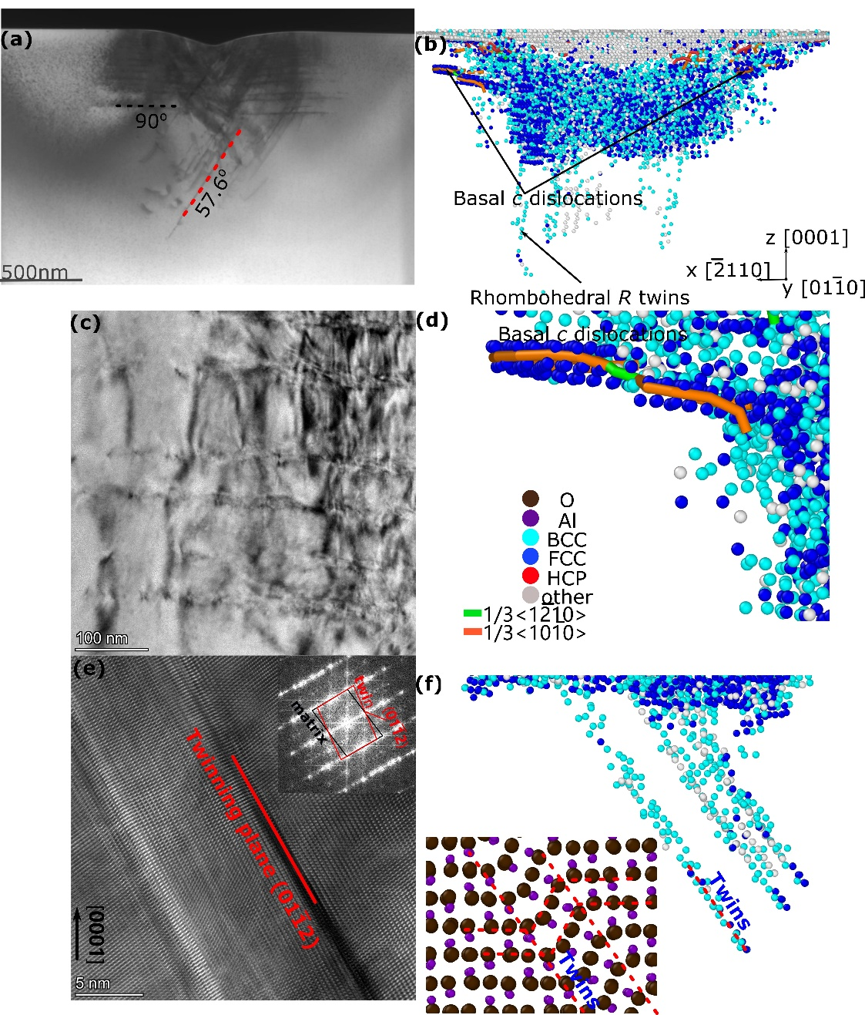
Fig. 5 TEM and MD simulation images of nanoindentation on the c-plane of the α-Al₂O₃ sample. Both basal c and rhombohedral R twins nucleate in α-Al₂O₃ according to indentation experiments and MD simulations. (a) TEM cross-section images of nanoindentation on the c-plane of α-Al₂O₃. (b) Sample cross-sections and atomistic configuration at depth δ = 6.0 nm with a loading velocity of ν = 100 m/s, shown in the main figure without perfect crystal atoms. (c) and (e) HRTEM images taken from areas containing dislocations and twins, with the FFT results inserted. (d) and (f) MD simulation images taken from areas containing basal dislocations and rhombohedral twins compared with TEM experiments. Only the dislocation atoms are shown for the sake of clarity. The signals are colored cyan, blue or gray depending on the local crystal structure. The BCC and FCC defective regions are indicated by cyan and blue, respectively. The surface atoms or twin boundary interfaces are colored gray.

The analysis reveals that the nucleation of parallel nanotwins is correlated with a slip plane deviation of approximately 57.6° from the boundary of the plastic region, suggesting the formation of a [] rhombohedral nanotwin, according to the Lee and Lagerlof table [62, 63]. This suggests that under indentation, the sapphire crystal undergoes significant deformation mechanisms involving both basal dislocations and twinning. Fig. 5(f) further confirms this by showing multiple rhombohedral twins [] from MD simulations, demonstrating how this twinning mechanism can enhance the ductility of sapphire under indentation.
Twinning in the R-plane is the dominant deformation mechanism for this specific orientation, as demonstrated in nano-scratching TEM experiments by Qiu et al. [64]. Unlike previous studies by Lin et al. [27], where pyramidal dislocations were reported, our study did not observe their nucleation under the experimental conditions applied. This suggests that basal slip and rhombohedral twinning are the primary deformation mechanisms for c-oriented α-Al₂O₃ under nanoindentation. The atomic plane stacking and crystal analysis further confirmed that the nucleation of parallel nanotwins was directly related to a slip plane deviation of 57.6°, reinforcing the formation of [] rhombohedral nanotwins. These results enhance our understanding of the interplay between basal dislocations and twin formation in sapphire, which plays a crucial role in influencing its mechanical response. The combination of experimental TEM imaging and MD simulations provides an inclusive picture of dislocation dynamics and defect interactions, thus providing valuable insights into the plastic deformation mechanisms of α-Al₂O₃.

3.3. Generalized stacking fault energy and deformation mechanisms
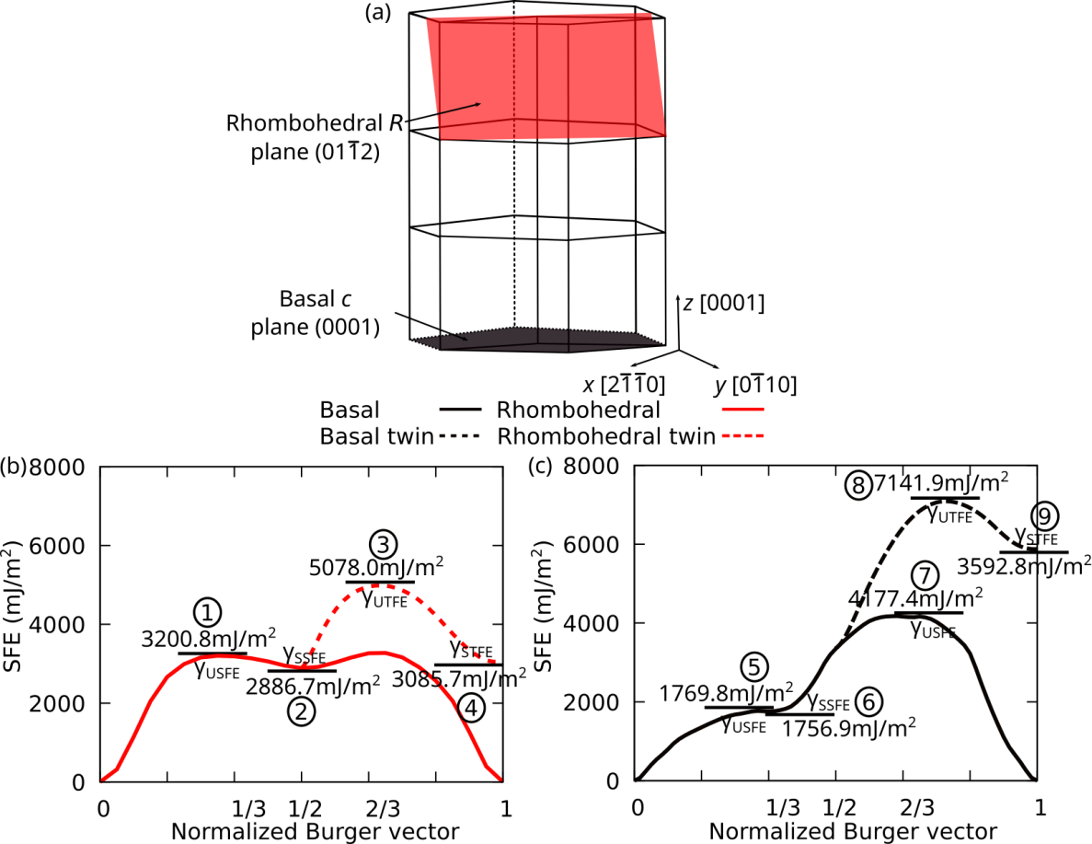
Fig. 6 Energy profiles of dislocation motion in α-Al₂O₃: (a) Illustration of the rhombohedral R-plane and basal (0001) c-plane twinning systems, GSFE and TFE curves for (b) rhombohedral and (c) basal dislocations.

Sapphire deformation is governed by several distinct mechanisms, including twinning (TW), SF, and full slip (FS). The primary host planes for twinning in sap-phire are the rhombohedral [] R-plane and the basal (0001) c plane, as illustrated in Fig. 6(a) [62, 65, 66]. These twinning mechanisms are crucial for understanding the plasticity of α-Al₂O₃, particularly under conditions such as nanoindentation and mechanical loading.
To quantify the energy barriers associated with these deformation mechanisms, the GSFE curves are employed, shown in Fig. 6(b)-(c). These curves characterize the energy penalty required to displace atomic planes within the crystal structure. Fig. 6(b) shows the GSFE profile for the rhombohedral [] slip system, where dislocations propagate along the Burgers vector direction. However, as previous studies have indicated, GSFE alone is insufficient to fully describe the complexity of deformation mechanisms in α-Al₂O₃ [67]. To provide a more comprehensive understanding, the twinning fault energy (TFE) curves for both [] rhombohedral and (0001) basal dislocations are presented in Figs. 6(b) and 6(c).
The GSFE curve for the rhombohedral slip system exhibits a single-hump profile, while the GSFE curve of the basal (0001) system displays multiple peaks, representing higher energy barriers for slip propagation. The key energy values are outlined. One is the unstable stacking fault energy (USFE). The first point (1) along the GSFE curve represents the energy required for gliding planes to overcome an energy barrier, leading to the nucleation of a leading partial dislocation. For the rhombohedral slip system, the USFE is γ_{USFE} = 3200.8 mJ/m². Another factor is SSFE. The second point (2) corresponds to the stable stacking fault configuration, where γ_{SSFE} = 2886.7 mJ/m² for the rhombohedral system.
Upon nucleation of a leading partial dislocation, there is competition between the three possible deformation mechanisms, which are now explicitly defined: FS, TW, and SF. The first possibility is full slip (FS), where a trailing partial dislocation nucleates to restore the original lattice structure. The second possibility is TW, in which a twin partial dislocation nucleates on an adjacent plane, creating a two-layer twin. The third possibility involves the formation of SF, where another leading partial dislocation nucleates on a non-adjacent plane, generating a consecutive stacking fault structure. For twinning deformation in the rhombohedral system, the unstable twinning fault energy (UTFE) is denoted as point (3) in Fig. 6(b), representing the energy barrier required to nucleate a twinning partial dislocation. The UTFE is γ_{UTFE} = 5078.0 mJ/m², after which a two-layer microtwin forms, corresponding to the stable twinning fault energy (STFE), γ_{STFE} = 3085.7 mJ/m², as confirmed in Fig. 5(f). In contrast, the basal slip system follows a different deformation pathway. Fig. 6(c) shows that the sixth point (6) along the basal dislocation trajectory corresponds to the nucleation of a trailing partial dislocation, forming an FS configuration. This occurs because of the significantly lower SSFE of γ_{SSFE} = 1756.9 mJ/m², as confirmed by Fig. 5(d).
Importantly, our GSFE and TFE analyses provide a quantitative ranking of the different deformation systems under c-plane indentation. Rhombohedral twinning results in the lowest energy barriers, basal twinning is intermediate, and basal full slip requires the highest stresses (CRSS ≈ 17 GPa), as illustrated in Figs. 5 and 6. This ranking provides a mechanistic explanation for the qualitative trends observed in both the experiments and simulations, and represents a new contribution by directly linking the energy values to the relative likelihood of each deformation mode.
For the c-plane orientation, the Schmid factor for basal partial dislocations is negligible (M ≈ 0), while the rhombohedral slip system has a significantly greater Schmid factor. The Schmid factor for a perfect dislocation is M = 0.45, whereas for a partial dislocation, it is M = 0.33 [39]. However, as shown in Fig. 5, basal partial dislocations are observed, perpendicular to the normal of the c plane, due to the complex forces applied by the indenter during nanoindentation. To quantify the resistance to deformation, the critical resolved shear stress (CRSS) for different slip and twinning systems at RT [68] is summarized in Table 1. Notably, the CRSS of the rhombohedral twin system is the lowest (0.111 GPa), indicating that it is the most easily activated deformation mode. The second-lowest CRSS corresponds to basal twinning, with a value of 0.148 GPa. In contrast, the basal perfect slip system has the highest CRSS (17 GPa), suggesting that it is the least favorable under normal deformation conditions. Pyramidal and rhombohedral dislocations are characterized by a slightly lower specific stresses and are typically observed at cryogenic temperatures [69, 70]. These values highlight that rhombohedral twinning is the most energetically favorable deformation mechanism under typical loading conditions, while basal perfect slip requires significantly higher stress and is rarely activated except under extreme conditions.
Furthermore, the critical resolved shear stress (CRSS) required to activate rhombohedral twinning (~0.1–0.2 GPa) is significantly lower than the intrinsic fracture strength of α-Al₂O₃ (20–30 GPa). This large disparity indicates that, under nanoscale loading, the crystal accommodates stress through twinning rather than crack initiation, which is consistent with the experimentally observed homogeneous plastic deformation.
The combined analysis of GSFE, TFE, and CRSS establishes a clear ranking of the active deformation mechanisms under c-plane indentation. The rhombohedral twinning system presents the lowest energy and stress barriers, followed by basal twinning, while basal perfect slip remains energetically unfavorable. This hierarchy explains the predominance of rhombohedral twins observed in both the MD simulations and post-indentation TEM analysis. These results are consistent with previous findings by Qiu et al. [64], who reported similar rhombohedral twin formation during nano-scratching, and by Montagne et al. [59], who related enhanced ductility to twin activity at small scales. In contrast, the present results differ from those of Lin et al. [27], where pyramidal slip was observed; this discrepancy likely arises from differences in indentation orientation and local stress distribution. Overall, the present GSFE–TFE framework provides a quantitative explanation for the experimentally observed sequence of deformation events and clarifies the energetically preferred mechanisms in α-Al₂O₃.

Table 1 CRSS for twin and slip systems in sapphire at room temperature [68].
Slip/twinning system | Dislocation type | CRSS (GPa)
 | Basal slip | 17.0
 | Rhombohedral slip | 3.0
 | Basal twinning | 0.148
 | Rhombohedral twinning | 0.111
 | Pyramidal slip | 1.65

The atomic mechanisms of slip and twinning in α-Al₂O₃ are further illustrated in Figs. 7 and 8. Fig. 7 describes the mechanism of rhombohedral slip and twinning. Initially, a perfect R-plane crystal is rotated by 57.6° around the axis, leading to a crystallographic orientation of x =, y =, and z =, as shown in Fig. 7(a). The distance at the interface between the Al atoms is . The gliding plane is then shifted along the y-direction, , as shown in Fig. 7(b), corresponding to point (1) in Fig. 6(b). The stable stacking fault (SSF) depicted by the red line is illustrated in Fig. 7(c) and corresponds to point (2) in Fig. 6(b). To form a twin, atoms must overcome the oxygen (O) sites, leading to the stacking of layers, as shown in Fig. 7(e). The final atomic configuration for the formation of a rhombohedral twin is depicted in Fig. 7(f).
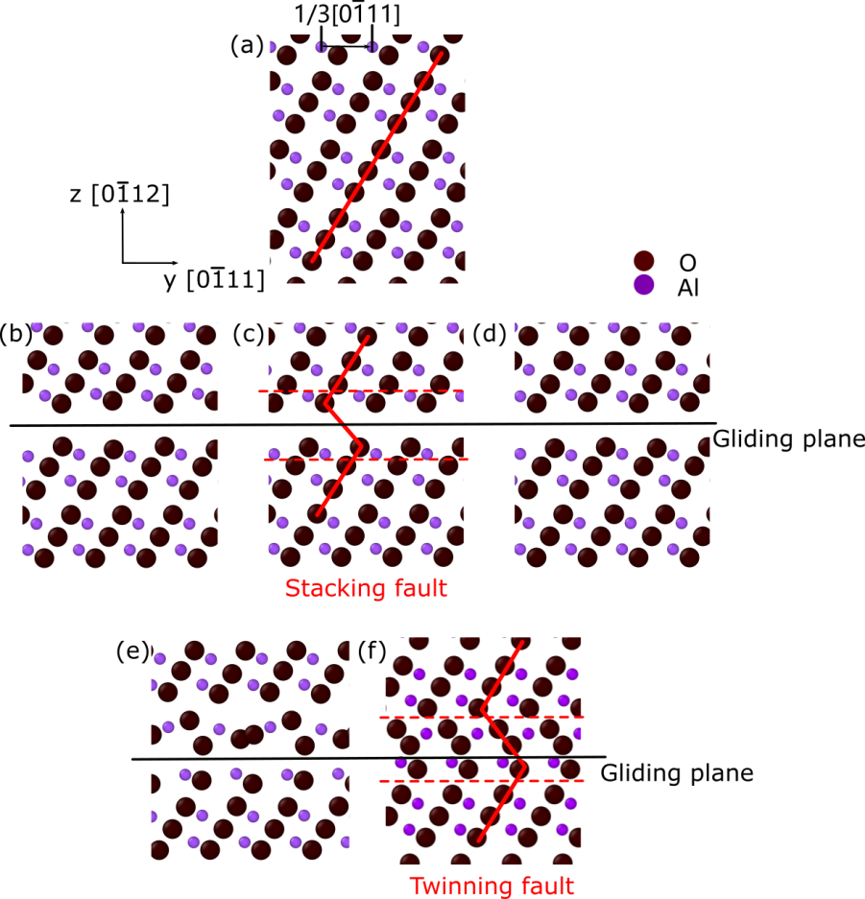
Fig. 7 Atomic-scale illustration of rhombohedral slip and twinning in α-Al₂O₃. (a–c) Evolution from the initial R-plane configuration to the formation of a stable SF (SSF) corresponding to point (2) in Fig. 6(b). (d–f) Successive layer shear and reordering across oxygen sites lead to the formation of a rhombohedral twin.
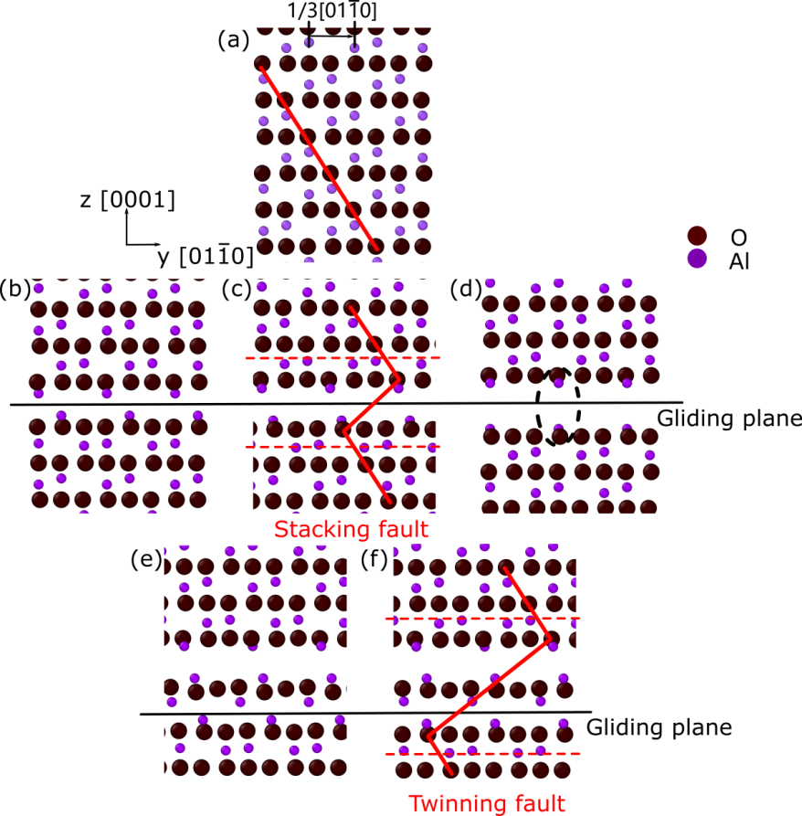
Fig. 8. Atomic-scale illustration of basal slip and twinning in α-Al₂O₃. (a–c) Formation of the USF and SSF along the basal plane, corresponding to point (6) in Fig. 6(c). (d–f) Sequential motion of basal partial dislocations on alternating layers produces a basal twin, although this mechanism is less favorable because of its higher twinning fault energy.
The motions of basal slip and twinning are presented in Fig. 8. The initial crystal structure before deformation is shown in Fig. 8(a), followed by the unstable SF (USF) in Fig. 8(b) and the SSF in Fig. 8(c). The SSF is outlined in red and corresponds to point (6) in Fig. 6(c). The gliding plane is shifted along the y-direction, . The distance at the interface between the Al atoms is . However, the movement of the partial dislocation along this direction is energetically unfavorable because of the close proximity of the cations, which generates high electrostatic energy [71]. This limitation is shown in Fig. 8(c) at point (7) and further illustrated in Fig. 8(d). After the SSF configuration of the basal partial dislocation is established, a basal twin can form by the successive movement of partial dislocations on alternating cation layers (see Fig. 8(f)). However, the STFE for basal twinning is significantly higher, as indicated by point (9) in Fig. 6(c), where γ_{STFE} = 3592.8 mJ/m².
These findings illustrate the complicated competition between different deformation mechanisms in α-Al₂O₃, governed by stacking fault energies, twinning fault energies, and critical resolved shear stresses. Rhombohedral twinning is the most favorable deformation mode under moderate stresses, while basal slip requires exceptionally high shear stress. The atomic-scale mechanisms further confirm that twinning and slip are fundamentally controlled by the crystallographic orientation and electrostatic interactions between cations and anions in the sapphire structure.
4 Concluding remarks
In summary, this study elucidates the nanoscale plasticity of c-plane α-Al₂O₃ through nanoindentation experiments and MD simulations, revealing homogeneous deformation without failure, driven by basal and rhombohedral twins. The consistent pop-in events and dislocation structures across scales validate the 2/3-body potential's predictive power. Unlike prior works, our GSFE/TFE calculations highlight the low-energy dominance of rhombohedral twinning, offering atomic-level insights into the deformation mechanism. These findings advance theoretical models for brittle oxides, with implications for enhancing the durability of sapphire. Future research should investigate temperature effects and multi-scale modeling to further bridge experimental-simulation gaps. This would pave the way for tailored high-strength ceramics in extreme environments.

Acknowledgements
We acknowledge support from the European Union Horizon 2020 research and innovation program under grant agreement no. 857470 and from the European Regional Development Fund via the Foundation for Polish Science International Research Agenda PLUS program grant No. MAB PLUS/2018/8. The publication was created within the framework of the project of the Minister of Science and Higher Education “Support for the activities of Centres of Excellence established in Poland under Horizon 2020” under contract no. MEiN/2023/DIR/3795. We acknowledge the computational resources provided by the High Performance Cluster at the National Centre for Nuclear Research in Poland.

CRediT authorship contribution statement
Q. Xu: Investigation, Software, Visualization, Writing – original draft. I. Goda: Formal analysis, Writing – original draft, Investigation. A. Zaborowska: Investigation, Visualization, Writing – original draft. K. Mulewska: Investigation, Formal analysis, Visualization. W. Chrominski: Investigation, Formal analysis. D. Kalita: Investigation, Formal analysis. Ł. Kurpaska: Formal analysis, Writing – review & editing. C. Fusco: Software, Writing – review & editing. F. Rovaris: Software, Writing – review & editing. W. Huo: Conceptualization, Methodology, Writing – review & editing, Supervision.

Declaration of competing interest
The authors have no competing interests to declare that are relevant to the content of this article.
References
[1] L. R. Dong, J. Zhang, Y. Z. Li, Y. X. Gao, M. Wang, M. X. Huang, J. S. Wang, K. X. Chen, Borrowed dislocations for ductility in ceramics, Science 385 (2024) 422-427.
[2] J.-S. Lee, J. Ji, U. Jeong, B.-J. Lee, An atomistic simulation study on ductility of amorphous aluminum oxide, Acta Mater. 274 (2024) 119985.
[3] Y. Li, H. Yan, S. Wang, X. Luo, Ł. Kurpaska, F. Fang, J. Jiang, H.S. Kim, W. Huo, Toward predictable phase structures in high-entropy oxides: A strategy for screening multicomponent compositions, Mat. Des. 248 (2024) 113497.
[4] S. Gong, X. Zhu, Y. Sun, B. Tang, Z. Su, Experimental research on surface characteristics and subsurface damage behavior of monocrystal sapphire induced by helical micro abrasive tools, Ceram. Int. 48 (15) (2022) 21500–21513.
[5] N. Shibata, M. F. Chisholm, A. Nakamura, S. J. Pennycook, T. Yamamoto, Y. Ikuhara, Nonstoichiometric dislocation cores in alpha-alumina, Science 316 (2007) 82–85.
[6] K.P. Lin, I. Stachiv, T.H. Fang, Mechanical properties and deformation mechanism of Al₂O₃ determined from in situ transmission electron microscopy compression, Mater. Res. Express 4 (2017) 075035.
[7] C. Ferraro, S. Meille, J. Rethore, N. Ni, J. Chevalier, E. Saiz, Strong and tough metal/ceramic micro-laminates, Acta. Mater. 144 (2018) 202–215.
[8] Q. Xu, J. Chevalier, J. Amodeo, Atomistic simulation of α-Al₂O₃ nanoparticle plastic anisotropy under compression, J. Am. Ceram. Soc. 106 (2023) 5986-5999.
[9] W. Huo, F. Fang, X. Liu, S. Tan, Z. Xie, J. Jiang, Remarkable strain-rate sensitivity of nanotwinned cocrfeni alloys, Appl. Phys. Lett. 114 (2019) 10.
[10] Y. Li, E. Lu, Ł. Kurpaska, F. Fang, T. Stasiak, H.S. Kim, W.J. Weber, Y. Zhang, W. Huo, Mo-driven strengthening mechanisms in cobalt-free Cr_{20-x}Fe₃₀Mn₂₀Ni₃₀Mo_{x} high-entropy alloys, Mater. Sci. Eng. A 946 (2025) 149150.
[11] A. Minor, J. Morris, E. Stach, Quantitative in situ nanoindentation in an electron microscope, Appl. Phys. Lett. 79 (11) (2001) 1625–1627.
[12] F. Östlund, K.R. Malyska, K. Leifer, L. M. Hale, Y. Tang, R. Ballarini, W.W. Gerberich, J. Michler, Brittle-to-ductile transition in uniaxial compression of silicon pillars at room temperature, Adv. Funct. Mater. 19 (15) (2009) 2439–2444.
[13] M.D. Uchic, D.M. Dimiduk, J.N. Florando, W.D. Nix, Sample dimensions influence strength and crystal plasticity, Science 305 (5686) (2004) 986–989.
[14] D. Kiener, W. Grosinger, G. Dehm, R. Pippan, A further step towards an understanding of size-dependent crystal plasticity: In situ tension experiments of miniaturized single-crystal copper samples, Acta Mater. 56 (3) (2008) 580–592.
[15] A. Sedlmayr, E. Bitzek, D.S. Gianola, G. Richter, R. Mönig, O. Kraft, Existence of two twinning-mediated plastic deformation modes in au nanowhiskers, Acta Mater. 60 (9) (2012) 3985–3993.
[16] S. Korte, W. Clegg, Micropillar compression of ceramics at elevated temperatures, Scr. Mater. 60 (9) (2009) 807–810.
[17] E. Calvié, L.J. Pottuz, C. Esnouf, P. Clément, V. Garnier, J. Chevalier, Y. Jorand, A. Malchère, T. Epicier, K.M. Varlot, Real time TEM observation of alumina ceramic nano-particles during compression, J. Eur. Ceram. Soc. 32 (10) (2012) 2067–2071.
[18] I. Issa, J. Amodeo, J. Réthoré, L.J. Pottuz, C. Esnouf, J. Morthomas, M. Perez, J. Chevalier, K.M. Varlot, In situ investigation of MgO nanocube deformation at room temperature, Acta Mater. 86 (2015) 295–304.
[19] I. Issa, C. Gammer, S. Kolitsch, A. Hohenwarter, P. J. Imrich, R. Pippan, D. Kiener, In-situ tem investigation of toughening in silicon at small scales, Mater. Today. 48 (2021) 29–37.
[20] E. Calvié, J. Réthoré, L. Joly-Pottuz, S. Meille, J. Chevalier, V. Garnier, Y. Jorand, C. Esnouf, T. Epicier, J. Quirk, et al., Mechanical behavior law of ceramic nanoparticles from transmission electron microscopy in situ nano-compression tests, Mater. Lett. 119 (2014) 107–110.
[21] J. Amodeo, S. Merkel, C. Tromas, P. Carrez, S.K. Kerzel, P. Cordier, J. Chevalier, Dislocations and plastic deformation in MgO crystals: a review, Crystals 8 (6) (2018) 240.
[22] K.P.D. Lagerlöf, A.H. Heuer, J. Castaing, J.P. Rivière, T.E. Mitchell, Slip and twinning in sapphire (α-Al₂O₃), J. Am. Ceram. Soc. 77 (2) (1994) 385–397.
[23] C.T. Le, T.T. Nguyen, T.T. Nguyen, V.V. Le, Molecular dynamics simulation of phase transformation and mechanical behavior in Al₂O₃ model, Vacuum 167 (2019) 175–181.
[24] K. Tsuruta, E. Tochigi, Y. Kezuka, K. Takata, N. Shibata, A. Nakamura, Y. Ikuhara, Core structure and dissociation energetics of basal edge dislocation in alpha-Al₂O₃: A combined atomistic simulation and transmission electron microscopy analysis, Acta. Mater. 65 (2014) 76–84.
[25] J. Lin, F. Jiang, Q. Wen, Y. Wu, J. Lu, Z. Tian, N. Wang, Deformation anisotropy of nano-scratching on c-plane of sapphire: A molecular dynamics study and experiment, Appl. Surf. Sci. 546 (2021) 149091.
[26] T. Carisey, I. Levin, D. Brandon, Microstructure and mechanical-properties of textured Al₂O₃, J. Eur. Ceram. Soc. 15 (4) (1995) 283–289.
[27] J. Lin, F. Jiang, X. Xu, J. Lu, Z. Tian, Q. Wen, X. Lu, Molecular dynamics simulation of nanoindentation on c-plane sapphire, Mech. Mater. 154 (2021) 103716.
[28] L. Boudoukha, F. Halitim, S. Paletto, G. Fantozzi, Mechanical properties of titanium implanted polycrystalline alumina and sapphire determined by nanoindentation, Ceram. Int. 24 (3) (1998) 189–198.
[29] A. Krell, S. Schädlich, Nanoindentation hardness of submicrometer alumina ceramics, Mater. Sci. Eng. A 307 (1-2) (2001) 172–181.
[30] W. Mao, Y. Shen, C. Lu, Deformation behavior and mechanical properties of polycrystalline and single crystal alumina during nanoindentation, Scr. Mater. 65 (2) (2011) 127–130.
[31] W. Mao, Y. Shen, C. Lu, Nanoscale elastic–plastic deformation and stress distributions of the c plane of sapphire single crystal during nanoindentation, J. Eur. Ceram. Soc. 31 (10) (2011) 1865–1871.
[32] V. Trabadelo, S. Pathak, F. Saeidi, M. Parlinska-Wojtan, K. Wasmer, Nanoindentation deformation and cracking in sapphire, Ceram. Int. 45 (8) (2019) 9835–9845.
[33] Y. Ma, L. Cao, W. Hang, T. Zhang, J. Yuan, Crystallographic orientation effect on the incipient plasticity and its stochastic behavior of a sapphire single crystal by spherical nanoindentation, Ceram. Int. 46 (10) (2020) 15554–15564.
[34] M. Matsui, A transferable interatomic potential model for crystals and melts in the system CaO-MgO-Al₂O₃ -SiO₂, Mineral. Mag. 58 (2) (1994) 571–572.
[35] W.C. Oliver, G.M. Pharr, An improved technique for determining hardness and elastic modulus using load and displacement sensing indentation experiments, J. Mater. Res. 7 (6) (1992) 1564–1583.
[36] F.G. Ferré, E. Bertarelli, A. Chiodoni, D. Carnelli, D. Gastaldi, P. Vena, M.G. Beghi, F. D. Fonzo, The mechanical properties of a nanocrystalline Al₂O₃/α-Al₂O₃ composite coating measured by nanoindentation and brillouin spectroscopy, Acta. Mater. 61 (7) (2013) 2662–2670.
[37] K.P.D. Lagerlof, B. Pletka, T. Mitchell, A. Heuer, Deformation and diffusion in sapphire (α-Al₂O₃), Radiat. Eff. 74 (1-4) (1983) 87–107.
[38] S. Plimpton, Fast parallel algorithms for short-range molecular dynamics, J. Comput. Phys. 117 (1) (1995) 1–19.
[39] Q. Xu, J. Chevalier, J. Amodeo, Atomistic simulation of α-Al₂O₃ nanoparticle plastic anisotropy under compression, J. Am. Ceram. Soc. 106 (10) (2023) 5986–5999.
[40] P. Vashishta, R.K. Kalia, A. Nakano, J.P. Rino, Interaction potentials for alumina and molecular dynamics simulations of amorphous and liquid alumina, J. Appl. Phys. 103 (8) (2008) 083504.
[41] Q. Xu, N. Salles, J. Chevalier, J. Amodeo, Atomistic simulation and interatomic potential comparison in α-Al₂O₃: lattice, surface and extended-defects properties, Model. Simul. Mat. Sci. Eng. 30 (3) (2022) 035008.
[42] E. Bitzek, P. Koskinen, F. Gähler, M. Moseler, P. Gumbsch, Structural relaxation made simple, Phys. Rev. Lett. 97 (17) (2006) 170201.
[43] W.G. Hoover, Canonical dynamics: Equilibrium phase-space distributions, Phys. Rev. A. 31 (3) (1985) 1695.
[44] T. Schneider, E. Stoll, Molecular-dynamics study of a three-dimensional one-component model for distortive phase transitions, Phys. Rev. B 17 (3) (1978) 1302.
[45] Q. Xu, A. Zaborowska, K. Mulewska, W. Huo, K. Karimi, F.J. Domı́nguez-Gutiérrez, L. Kurpaska, M.J. Alava, S. Papanikolaou, Atomistic insights into nanoindentation-induced deformation of α-Al₂O₃ single crystals, Vacuum 219 (2024) 112733.
[46] A. Stukowski, Visualization and analysis of atomistic simulation data with ovito–the open visualization tool, Model. Simul. Mat. Sci. Eng. 18 (1) (2009) 015012.
[47] A. Stukowski, K. Albe, Extracting dislocations and non-dislocation crystal defects from atomistic simulation data, Model. Simul. Mat. Sci. Eng. 18 (8) (2010) 085001.
[48] W. Lee, K. Lagerlof, Structural and electron diffraction data for sapphire (α-Al₂O₃), J. Electron. Microsc. Tech. 2 (3) (1985) 247–258.
[49] E. Sánchez-González, J.J. Meléndez-Martı́nez, A. Pajares, P. Miranda, F. Guiberteau, B.R. Lawn, Application of hertzian tests to measure stress–strain characteristics of ceramics at elevated temperatures, J. Am. Ceram. Soc. 90 (1) (2007) 149–153.
[50] S. Ruppi, A. Larsson, A. Flink, Nanoindentation hardness, texture and microstructure of α-Al₂O₃ and κ-Al₂O₃ coatings, Thin Solid Films 516 (18) (2008) 5959–5966.
[51] X. Liu, E. Haimi, S.P. Hannula, O.M. Ylivaara, R.L. Puurunen, On the reliability of nanoindentation hardness of Al₂O₃ films grown on si-wafer by atomic layer deposition, J. Vac. Sci. Technol. 32 (1) (2014).
[52] F. Konstantiniuk, M. Tkadletz, C. Kainz, C. Czettl, N. Schalk, Mechanical properties of single and polycrystalline α-Al₂O₃ coatings grown by chemical vapor deposition, Surf. Coat. Technol. 410 (2021) 126959.
[53] K. Sanami, M. Shahien, A. Yumoto, J. Akedo, K. Shinoda, Evaluating the mechanical properties of dense hybridaerosol deposition alumina coatings using the nanoindentation method, JTST 1432 (2-3) (2023) 729–736.
[54] D. Mordehai, S-W . Lee, B. Backes, D.J. Srolovitz, W.D. Nix, E. Rabkin. Size effect in compression of single-crystal gold microparticles. Acta Mater. 59 (2011) 5202–15.
[55] T. Zhu, J. Li, A. Samanta, A. Leach, K. Gall. Temperature and Strain-Rate Dependence of Surface Dislocation Nucleation. Phys Rev Lett 100 (2008) 025502.
[56] I. Issa, J. Amodeo, J. Réthoré, L. Joly-Pottuz, C. Esnouf, J. Morthomas, M. Perez, J. Chevalier, K. Masenelli-Varlot. In situ investigation of MgO nanocube deformation at room temperature. Acta Mater 86 (2015) 295-304.
[57] D.Q. Doan, T.H. Fang, A.S. Tran, T.H. Chen, Residual stress and elastic recovery of imprinted cu-zr metallic glass films using molecular dynamic simulation, Comput. Mater. Sci. 170 (2019) 109162.
[58] Q. Hsu, C. Wu, T. Fang, Studies on nanoimprint process parameters of copper by molecular dynamics analysis, Comput. Mater. Sci. 34 (4) (2005) 314–322.
[59] A. Montagne, S. Pathak, X. Maeder, J. Michler, Plasticity and fracture of sapphire at room temperature: Load- controlled microcompression of four different orientations, Ceram. Int. 40 (1) (2014) 2083–2090.
[60] T. Zhang, F. Jiang, H. Huang, J. Lu, Y. Wu, Z. Jiang, X. Xu. Towards understanding the brittle–ductile transition in the extreme manufacturing. IJEM 3 (2021) 022001.
[61] K. Wang, F. Jiang, Y. Li, N. Wang, Z. Hu, L. Yan, J. Lu, Q. Wen, X. Lu. Prediction of pop-in load for sapphires with different crystal orientations. Ceram. Int. 46 (2020) 6682-6692.
[62] K. Lagerlöf, J. Castaing, P. Pirouz, A. Heuer, Nucleation and growth of deformation twins: a perspective based on the double-cross-slip mechanism of deformation twinning, Philos. Mag. 82 (15) (2002) 2841–2854.
[63] A.Y. Kuksin, A. Yanilkin, Formation of twins in sapphire under shock wave loading: atomistic simulations, J. Appl. Phys.111 (3) (2012) 033513.
[64] T. Qiu, F. Jiang, N. Wang, J. Lin, Z. Tian, Y. Wu, Q. Wen, J. Lu. Atomistic understanding of the variable nano-hardness of C-plane sapphire considering the crystal anisotropy. JMRT 29 (2024). 4514-4525.
[65] A. Heuer, Deformation twinning in corundum, Philosophical Magazine 13 (122) (1966) 379–393.
[66] W.D. Scott, K. Orr, Rhombohedral twinning in alumina, J. Am. Ceram. Soc. 66 (1) (1983) 27–32.
[67] M. Jo, Y.M. Koo, B.J. Lee, B. Johansson, L. Vitos, S.K. Kwon, Theory for plasticity of face-centered cubic metals, PNAS 111 (18) (2014) 6560–6565.
[68] R. Nowak, M. Sakai, The anisotropy of surface deformation of sapphire: Continuous indentation of triangular indenter, Acta. Mater. 42 (8) (1994) 2879–2891.
[69] Ö. Ünal, K.P.D. Lagerlöf, Tensile properties of alumina fibers using hot-grips, J. Am. Ceram. Soc. 77 (10) (1994) 2609–2614.
[70] H.T. Kim, High thermal conductivity ceramics and their composites for thermal management of integrated electronic packaging, Heat Transfer-Models, Methods and Applications (2018) 333–359.
[71] A. Heuer, C. Jia, K. Lagerlöf, The core structure of basal dislocations in deformed sapphire (α-Al₂O₃), Science 330 (6008) (2010) 1227–1231.

